***This is a bonus Web chapter

CHAPTER 42

Servlets

Objectives

- To explain how a servlet works (§42.2).
- To create/develop/run servlets (§42.3).
- To deploy servlets on application servers such as Tomcat and GlassFish (§42.3).
- To describe the servlets API (§42.4).
- To create simple servlets (§42.5).
- To create and process HTML forms (§42.6).
- To develop servlets to access databases (§42.7).
- To use hidden fields, cookies, and HttpSession to track sessions (§42.8).
- To send images from servlets (§42.9).

42.1 Introduction
<Side Remark: servlet>
Servlets are Java programs that run on a Web server. They can be used to process client requests or produce dynamic Web pages. For example, you can write servlets to generate dynamic Web pages that display stock quotes or process client registration forms and store registration data in a database. This chapter introduces the concept of Java servlets. You will learn how to develop Java servlets using NetBeans.

NOTE:
<Side Remark: why NetBeans?>
You can develop servlets without using an IDE. However, using an IDE such as NetBeans can greatly simplify the development task. The tool can automatically create the supporting directories and files. We choose NetBeans because it has the best support for Java Web development. You can still use your favorite IDE or no IDE for this chapter.

NOTE:
<Side Remark: why servlets?>
Servlets are the foundation of Java Web technologies. JSP, JSF, and Java Web services are based on servlets. A good understanding of servlets helps you see the big picture of Java Web technology and learn JSP, JSF, and Web services.

42.2 HTML and Common Gateway Interface
Java servlets run in the Web environment. To understand Java servlets, let us review HTML and the Common Gateway Interface (CGI).

42.2.1 Static Web Contents
You create Web pages using HTML. Your Web pages are stored as files on the Web server. The files are usually stored in the /htdocs directory on Unix, as shown in Figure 42.1. A user types a URL for the file from a Web browser. The browser contacts the Web server and requests the file. The server finds the file and returns it to the browser. The browser then displays the file to the user. This works fine for static information that does not change regardless of who requests it or when it is requested. Static information is stored in files. The information in the files can be updated, but at any given time every request for the same document returns exactly the same result.
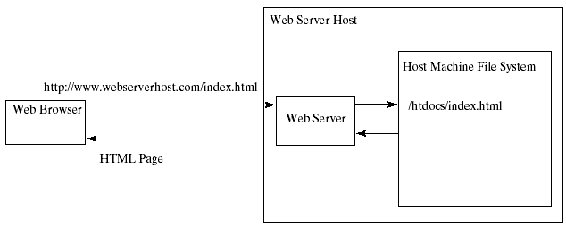

Figure 42.1
A Web browser requests a static HTML page from a Web server.

42.2.2 Dynamic Web Contents and Common Gateway Interface
Not all information, however, is static in nature. Stock quotes are updated whenever a trade takes place. Election vote counts are updated constantly on Election Day. Weather reports are frequently updated. The balance in a customer’s bank account is updated whenever a transaction takes place. To view up-to-date information on the Web, the HTML pages for displaying this information must be generated dynamically. Dynamic Web pages are generated by Web servers. The Web server needs to run certain programs to process user requests from Web browsers in order to produce a customized response.

<Side Remark: CGI>
The Common Gateway Interface, or CGI, was proposed to generate dynamic Web content. The interface provides a standard framework for Web servers to interact with external programs, known as CGI programs. As shown in Figure 42.2, the Web server receives a request from a Web browser and passes it to the CGI program. The CGI program processes the request and generates a response at runtime. CGI programs can be written in any language, but the Perl language is the most popular choice. CGI programs are typically stored in the /cgi-bin directory. Here is a pseudocode example of a CGI program for displaying a customer’s bank account balance:

- Obtain account ID and password.
- Verify account ID and password. If it fails, generate an HTML page to report incorrect account ID and password, and exit.
- Retrieve account balance from the database; generate an HTML page to display the account ID and balance.

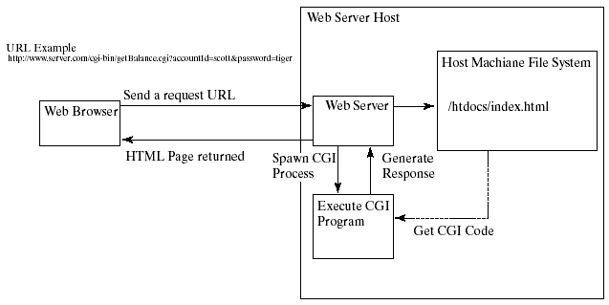

Figure 42.2
A Web browser requests a dynamic HTML page from a Web server.

42.2.3 The GET and POST Methods
<Side Remark: query string>
The two most common HTTP requests, also known as methods, are GET and POST. The Web browser issues a request using a URL or an HTML form to trigger the Web server to execute a CGI program. HTML forms will be introduced in §42.6, “HTML Forms.” When issuing a CGI request directly from a URL, the GET method is used. This URL is known as a query string. The URL query string consists of the location of the CGI program, the parameters, and their values. For example, the following URL causes the CGI program getBalance to be invoked on the server side:
http://www.webserverhost.com/cgi-bin/
getBalance.cgi?accountId=scott+smith&password=tiger

The ? symbol separates the program from the parameters. The parameter name and value are associated using the = symbol. Parameter pairs are separated using the & symbol. The + symbol denotes a space character. So, here accountId is scott smith.

When issuing a request from an HTML form, either a GET method or a POST method can be used. The form explicitly specifies one of these. If the GET method is used, the data in the form are appended to the request string as if it were submitted using a URL. If the POST method is used, the data in the form are packaged as part of the request file. The server program obtains the data by reading the file. The POST method is more secure than the GET method.

NOTE
<Side Remark: GET vs. POST>
The GET and POST methods both send requests to the Web server. The POST method always triggers the execution of the corresponding CGI program. The GET method may not cause the CGI program to be executed, if the previous same request is cached in the Web browser. Web browsers often cache Web pages so that the same request can be quickly responded to without contacting the Web server. The browser checks the request sent through the GET method as a URL query string. If the results for the exact same URL are cached on a disk, then the previous Web pages for the URL may be displayed. To ensure that a new Web page is always displayed, use the POST method. For example, use a POST method if the request will actually update the database. If your request is not time sensitive, such as finding the address of a student in the database, use the GET method to speed up performance.

42.2.4 From CGI to Java Servlets
<Side Remark: CGI vs. servlets>
CGI provides a relatively simple approach for creating dynamic Web applications that accept a user request, process it on the server side, and return responses to the Web browser. But CGI is very slow when handling a large number of requests simultaneously, because the Web server spawns a process for executing each CGI program. Each process has its own runtime environment that contains and runs the CGI program. It is not difficult to imagine what will happen if many CGI programs were executed simultaneously. System resource would be quickly exhausted, potentially causing the server to crash.

<Side Remark: servlet engine>
Several new approaches have been developed to remedy the performance problem of CGI programs. Java servlets are one successful technology for this purpose. Java servlets are Java programs that function like CGI programs. They are executed upon request from a Web browser. All servlets run inside a servlet container, also referred to as a servlet server or a servlet engine. A servlet container is a single process that runs in a Java Virtual Machine. The JVM creates a thread to handle each servlet. Java threads have much less overhead than full-blown processes. All the threads share the same memory allocated to the JVM. Since the JVM persists beyond the life cycle of a single servlet execution, servlets can share objects already created in the JVM. For example, if multiple servlets access the same database, they can share the connection object. Servlets are much more efficient than CGI.

Servlets have other benefits that are inherent in Java. As Java programs, they are object oriented, portable, and platform independent. Since you know Java, you can develop servlets immediately with the support of Java API for accessing databases and network resources.

42.3 Creating and Running Servlets
<side remark: Tomcat>
<side remark: GlassFish>
To run Java servlets, you need a servlet container. Many servlet containers are available for free. Two popular ones are Tomcat (developed by Apache, www.apache.org) and GlassFish (developed by Sun, glassfish.dev.java.net). Both Tomcat and GlassFish are bundled and integrated with NetBeans 7 (Java EE version). When you run a servlet from NetBeans, Tomcat or GlassFish will be automatically started. You can choose to use either of them, or any other application server. GlassFish has more features than Tomcat and it takes more system resource.

42.3.1 Creating a Servlet
Before our introduction to the servlet API, let us look at a simple example to see how servlets work. A servlet to some extent resembles an applet. Every Java applet is a subclass of the Applet class. You need to override appropriate methods in the Applet class to implement the applet. Every servlet is a subclass of the HttpServlet class. You need to override appropriate methods in the HttpServlet class to implement the servlet. Listing 42.1 is a servlet that generates a response in HTML using the doGet method.

Listing 42.1 FirstServlet.java
<Side Remark line 11: process GET>
<Side Remark line 14: content type>
<Side Remark line 15: output to browser>
<Side Remark line 25: close stream>

package chapter42;

import javax.servlet.*;
import javax.servlet.http.*;

public class FirstServlet extends HttpServlet {
/** Handle the HTTP GET method.
* @param request servlet request
* @param response servlet response
*/
protected void doGet(HttpServletRequest request,
HttpServletResponse response)
throws ServletException, java.io.IOException {
response.setContentType("text/html");
java.io.PrintWriter out = response.getWriter();
// output your page here
out.println("<html>");
out.println("<head>");
out.println("<title>Servlet</title>");
out.println("</head>");
out.println("<body>");
out.println("Hello, Java Servlets");
out.println("</body>");
out.println("</html>");
out.close();
}
}

<Side Remark: request>
<Side Remark: response>
<Side Remark: PrintWriter>
The doGet method (line 11) is invoked when the Web browser issues a request using the GET method. The doGet method has two parameters, request and response. request is for obtaining data from the Web browser and response is for sending data back to the browser. Line 14 indicates that data are sent back to the browser as text/html. Line 15 obtains an instance of PrintWriter for actually outputing data to the browser.

42.3.2 Creating Servlets in NetBeans

<Side Remark: create a Web project>
NetBeans is updated frequently. The current version is 7.0 at the time of this writing. To create a servlet in NetBeans 7, you have to first create a Web project, as follows:

- Choose File › New Project to display the New Project dialog box. Choose Java Web in the Categories section and Web Application in the Projects section, as shown in Figure 42.3a. Click Next to display the New Web Application dialog box, as shown in Figure 42.3b.
- Enter liangweb in the Project Name field and c:\book in the Project Location field. Check Set as Main Project. Click Next to display the dialog box for specifying server and settings, as shown in Figure 42.4.

- Select Apache Tomcat 7.0.11 for server and Java EE 5 for J2EE Version. Click Finish to create the Web project, as shown in Figure 42.5.

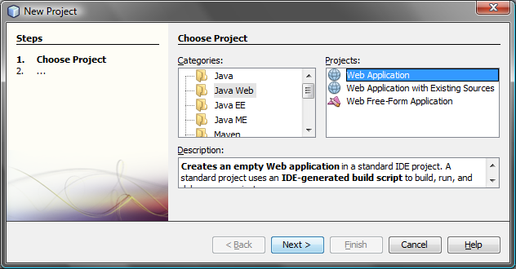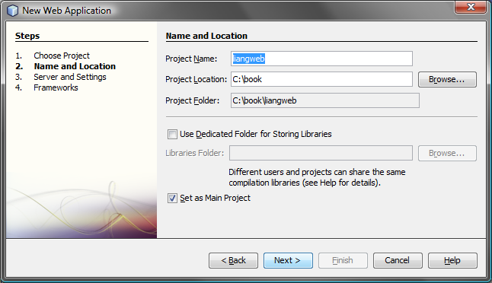
(a) (b)

Figure 42.3
(a) Choose Web Application to create a Web project. (b) Specify project name and location.
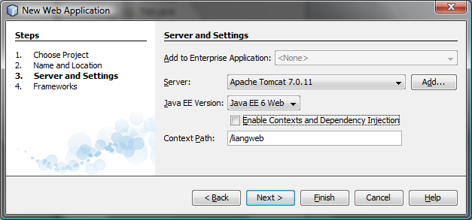

Figure 42.4
Choose servers and settings.
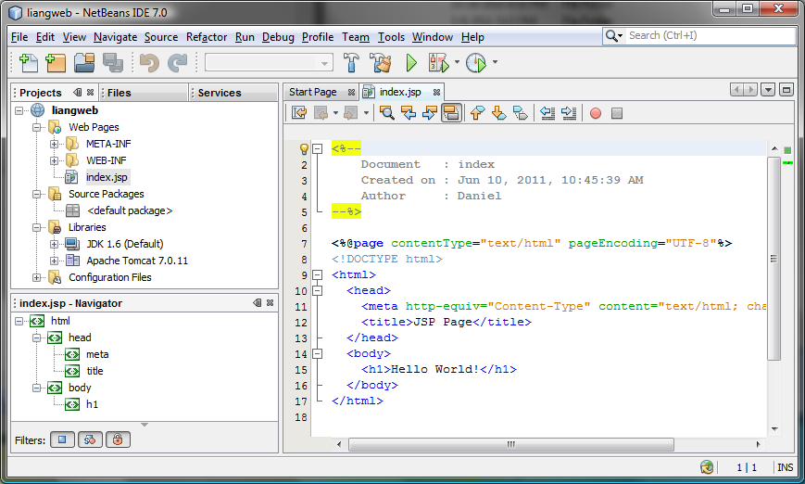

Figure 42.5
A new Web project is created.
Now you can create a servlet in the project, as follows:

<Side Remark: create a servlet>
- Right-click the liangweb node in the project pane to display a context menu. Choose New › Servlet to display the New Servlet dialog box, as shown in Figure 42.6.
- Enter FirstServlet in the Class Name field and chapter42 in the Package field and click Next to display the Configure Servlet Deployment dialog box, as shown in Figure 42.7.
- Select the checkbox to add the servlet information to web.xml and click Finish to create the servlet. A servlet template is now created in the project, as shown in Figure 42.8.
- Replace the code in the content pane for the servlet using the code in Listing 42.1.
<Side Remark: run a servlet>
- Right-click liangweb node in the Project pane to display a context menu and choose Run to launch the Web server. In the Web browser, enter http://localhost:8084/liangweb/FirstServlet in the URL. You will now see the servlet result displayed, as shown in Figure 42.9.

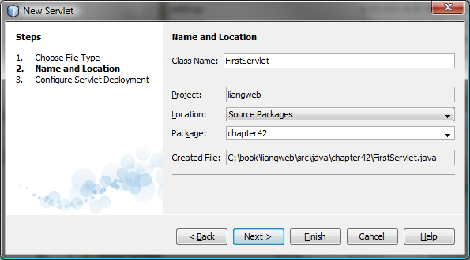

Figure 42.6
You can create a servlet in the New Servlet dialog box.
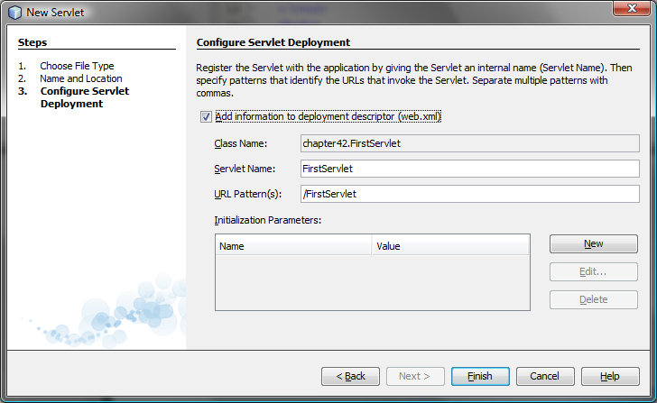

Figure 42.7
You need to click the checkbox to add servlet information to web.xml.
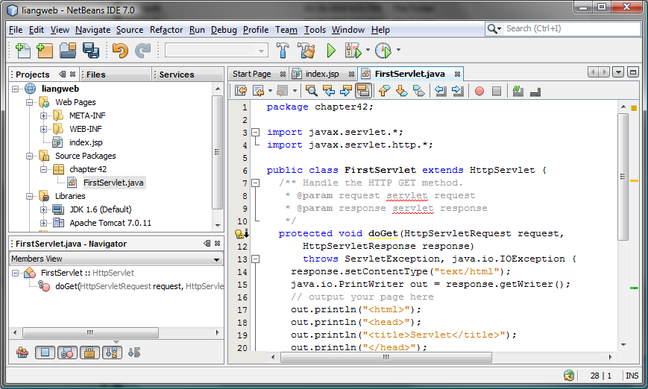

Figure 42.8
A new servlet class is created in the project.
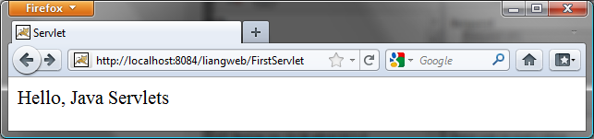

Figure 42.9
Servlet result is displayed in a Web browser.
NOTE
<Side Remark: IDE issues>
If the servlet is not displayed in the browser, do the following: 1. Make sure you have you have added the servlet in the xml.web file. 2. Right-click liangweb and choose Clean and Build. 3. Right-click liangweb and choose Run. Reenter http://localhost:8084/liangweb/FirstServlet in the URL. If still not working, exit NetBeans and restart it.
***End of NOTE

NOTE
<Side Remark: port number>
Depending on the server setup, you may have a port number other than 8084.
***End of NOTE

TIP
<Side Remark: deploy Web project>
<Side Remark: WAR file>
You can deploy a Web application using a Web archive file (WAR) to a Web application server (e.g., Tomcat). To create a WAR file for the liangweb project, right-click liangweb and choose Build Project. You can now locate liangweb.war in the c:\book\liangweb\dist folder. To deploy on Tomcat, simply place liangweb.war into the webapps directory. When Tomcat starts, the .war file will be automatically installed.
NOTE:
<side remark: Tomcat Tutorial>
If you wish to use NetBeans as the development tool and Tomcat as the deployment server, please see Supplement V.E, “Tomcat Tutorial.”

42.4 The Servlet API
You have to know the servlet API in order to understand the source code in FirstServlet.java. The servlet API provides the interfaces and classes that support servlets. These interfaces and classes are grouped into two packages, javax.servlet and javax.servlet.http, as shown in Figure 42.10. The javax.servlet package provides basic interfaces, and the javax.servlet.http package provides classes and interfaces derived from them, which provide specific means for servicing HTTP requests.
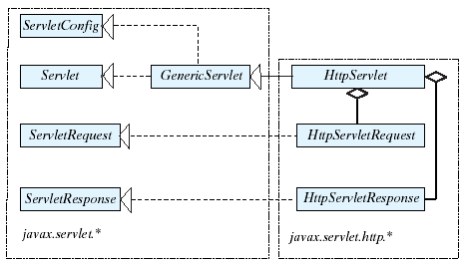

Figure 42.10
The servlet API contains interfaces and classes that you use to develop and run servlets.

42.4.1 The Servlet Interface
The javax.servlet.Servlet interface defines the methods that all servlets must implement. The methods are listed below:
/** Invoked for every servlet constructed */
public void init() throws ServletException;

/** Invoked to respond to incoming requests */
public void service(ServletRequest request, ServletResponse response)
throws ServletException, IOException;

/** Invoked to release resource by the servlet */
public void destroy();

<Side Remark: servlet life cycle>
The init, service, and destroy methods are known as life-cycle methods and are called in the following sequence (see Figure 42.11):
1. The init method is called when the servlet is first created and is not called again as long as the servlet is not destroyed. This resembles an applet’s init method, which is invoked after the applet is created and is not invoked again as long as the applet is not destroyed.
2. The service method is invoked each time the server receives a request for the servlet. The server spawns a new thread and invokes service.
3. The destroy method is invoked after a timeout period has passed or as the Web server is terminated. This method releases resources for the servlet.
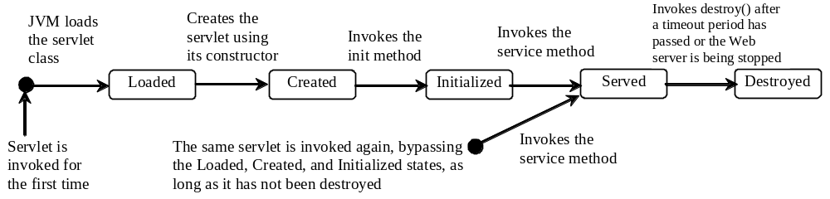

Figure 42.11
The JVM uses the init, service, and destroy methods to control the servlet.

42.4.2 The GenericServlet Class, ServletConfig Interface, and HttpServlet Class
The javax.servlet.GenericServlet class defines a generic, protocol-independent servlet. It implements javax.servlet.Servlet and javax.servlet.ServletConfig. ServletConfig is an interface that defines four methods (getInitParameter, getInitParameterNames, getServletContext, and getServletName) for obtaining information from a Web server during initialization. All the methods in Servlet and ServletConfig are implemented in GenericServlet except service. Therefore, GenericServlet is an abstract class.

The javax.servlet.http.HttpServlet class defines a servlet for the HTTP protocol. It extends GenericServlet and implements the service method. The service method is implemented as a dispatcher of HTTP requests. The HTTP requests are processed in the following methods:
- doGet is invoked to respond to a GET request.
- doPost is invoked to respond to a POST request.
- doDelete is invoked to respond to a DELETE request. Such a request is normally used to delete a file on the server.
- doPut is invoked to respond to a PUT request. Such a request is normally used to send a file to the server.
- doOptions is invoked to respond to an OPTIONS request. This returns information about the server, such as which HTTP methods it supports.
- doTrace is invoked to respond to a TRACE request. Such a request is normally used for debugging. This method returns an HTML page that contains appropriate trace information.
All these methods use the following signature:
protected void doXxx(HttpServletRequest req, HttpServletResponse resp)
throws ServletException, java.io.IOException

The HttpServlet class provides default implementation for these methods. You need to override doGet, doPost, doDelete, and doPut if you want the servlet to process a GET, POST, DELETE, or PUT request. By default, nothing will be done. Normally, you should not override the doOptions method unless the servlet implements new HTTP methods beyond those implemented by HTTP 1.1. Nor is there any need to override the doTrace method.

NOTE: GET and POST requests are often used, whereas DELETE, PUT, OPTIONS, and TRACE are not. For more information about these requests, please refer to the HTTP 1.1 specification from www.cis.ohio-state.edu/htbin/rfc/rfc2068.html.
NOTE: Although the methods in HttpServlet are all nonabstract, HttpServlet is defined as an abstract class. Thus you cannot create a servlet directly from HttpServlet. Instead you have to define your servlet by extending HttpServlet.
The relationship of these interfaces and classes is shown in Figure 42.12.
<PD: UML Class Diagram>
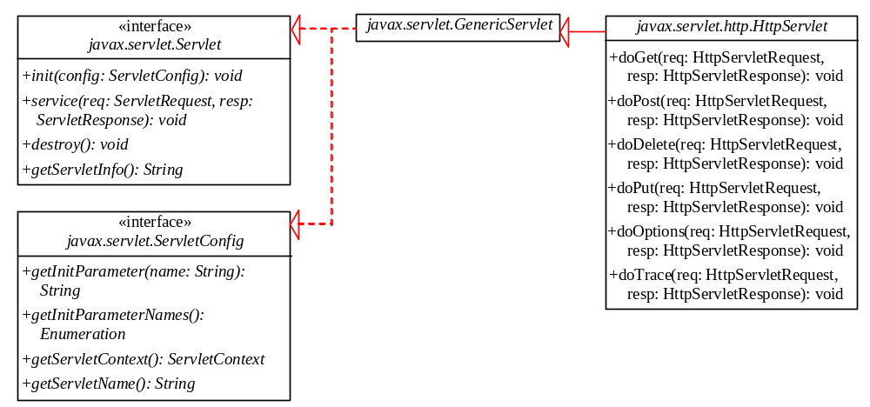

Figure 42.12
HttpServlet inherits abstract class GenericServlet, which implements interfaces Servlet and ServletConfig.

42.4.3 The ServletRequest Interface and HttpServletRequest Interface
Every doXxx method in the HttpServlet class has a parameter of the HttpServletRequest type, which is an object that contains HTTP request information, including parameter name and values, attributes, and an input stream. HttpServletRequest is a subinterface of ServletRequest. ServletRequest defines a more general interface to provide information for all kinds of clients. The frequently used methods in these two interfaces are shown in Figure 42.13.
<PD: UML Class Diagram>
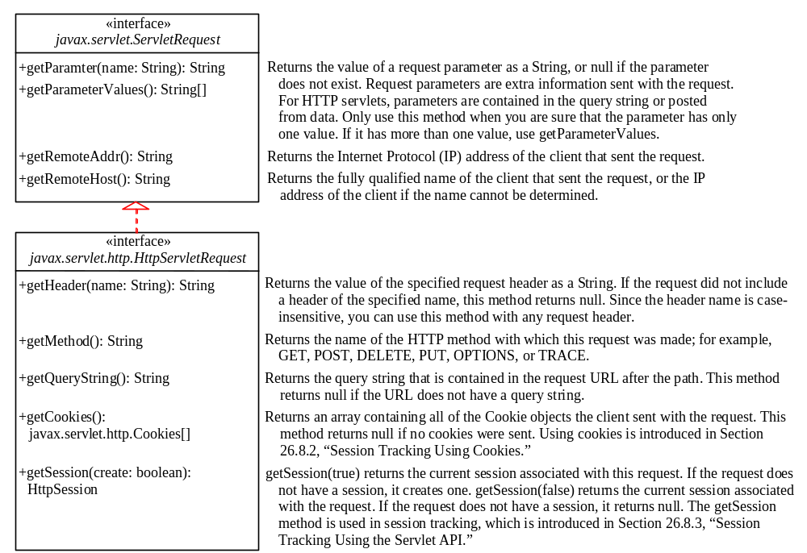

Figure 42.13
HttpServletRequest is a subinterface of ServletRequest.

42.4.4 The ServletResponse Interface and HttpServletResponse Interface
Every doXxx method in the HttpServlet class has a parameter of the HttpServletResponse type, which is an object that assists a servlet in sending a response to the client. HttpServletResponse is a subinterface of ServletResponse. ServletResponse defines a more general interface for sending output to the client.

The frequently used methods in these two interfaces are shown in Figure 42.14.

<PD: UML Class Diagram>
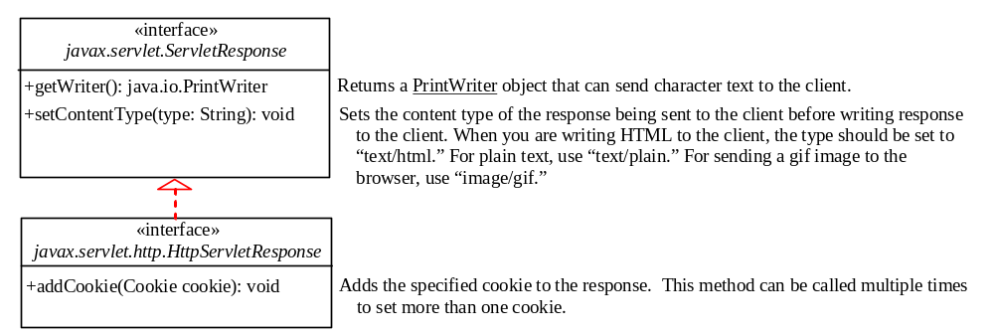

Figure 42.14
HttpServletResponse is a subinterface of ServletResponse.

42.5 Creating Servlets
Servlets are the opposite of Java applets. Java applets run from a Web browser on the client side. To write Java programs, you define classes. To write a Java applet, you define a class that extends the Applet class. The Web browser runs and controls the execution of the applet through the methods defined in the Applet class. Similarly, to write a Java servlet, you define a class that extends the HttpServlet class. The servlet container runs and controls the execution of the servlet through the methods defined in the HttpServlet class. Like a Java applet, a servlet does not have a main method. A servlet depends on the servlet engine to call the methods. Every servlet has a structure like the one shown below:

package chapter42;

import javax.servlet.*;
import javax.servlet.http.*;
import java.io.*;

public class MyServlet extends HttpServlet {
/** Called by the servlet engine to initialize servlet */
public void init() throws ServletException {
...
}

/** Process the HTTP Get request */
public void doGet(HttpServletRequest request, HttpServletResponse
response) throws ServletException, IOException {
...
}

/** Process the HTTP Post request */
public void doPost(HttpServletRequest request, HttpServletResponse
response) throws ServletException, IOException {
...
}

/** Called by the servlet engine to release resource */
public void destroy() {
...
}

// Other methods if necessary
}

The servlet engine controls the servlets using init, doGet, doPost, destroy, and other methods. By default, the doGet and doPost methods do nothing. To handle a GET request, you need to override the doGet method; to handle a POST request, you need to override the doPost method.

Listing 42.2 gives a simple Java servlet that generates a dynamic Web page for displaying the current time, as shown in Figure 42.15.

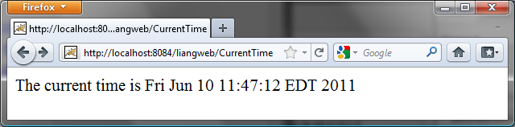
Figure 42.15
Servlet CurrentTime displays the current time.
Listing 42.2 CurrentTime.java
<Side Remark line 9: process GET>
<Side Remark line 11: content type>
<Side Remark line 12: output to browser>
<Side Remark line 14: close stream>
package chapter42;

import javax.servlet.*;
import javax.servlet.http.*;
import java.io.*;

public class CurrentTime extends HttpServlet {
/** Process the HTTP Get request */
public void doGet(HttpServletRequest request, HttpServletResponse
response) throws ServletException, IOException {
response.setContentType("text/html");
PrintWriter out = response.getWriter();
out.println("<p>The current time is " + new java.util.Date());
out.close(); // Close stream
}
}
The HttpServlet class has a doGet method. The doGet method is invoked when the browser issues a request to the servlet using the GET method. Your servlet class should override the doGet method to respond to the GET request. In this case, you write the code to display the current time.

Servlets return responses to the browser through an HttpServletResponse object. Since the setContentType("text/html") method sets the MIME type to “text/html,” the browser will display the response in HTML. The getWriter method returns a PrintWriter object for sending HTML back to the client.

NOTE: The URL query string uses the GET method to issue a request to the servlet. The current time may not be current if the Web page for displaying the current time is cached. To ensure that a new current time is displayed, refresh the page in the browser. In the next example, you will write a new servlet that uses the POST method to obtain the current time.

42.6 HTML Forms
HTML forms enable you to submit data to the Web server in a convenient form. As shown in Figure 42.16, the form can contain text fields, text area, check boxes, combo boxes, lists, radio buttons, and buttons.

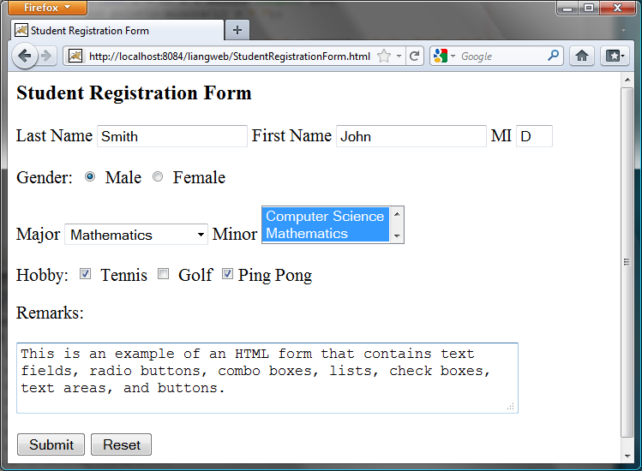

Figure 42.16
An HTML form may contain text fields, radio buttons, combo boxes, lists, check boxes, text areas, and buttons.
<Side Remark: HTML/XHTML Tutorial>
The HTML code for creating the form in Figure 42.16 is given in Listing 42.3. (If you are unfamiliar with HTML, please see Supplement V.A, “HTML and XHTML Tutorial.”)

Listing 42.3 StudentRegistrationForm.html
<Side Remark line 9: form tag>
<Side Remark line 12: label>
<Side Remark line 13: text field>
<Side Remark line 21: radio button>
<Side Remark line 26: combo box>
<Side Remark line 35: list>
<Side Remark line 44: check box>
<Side Remark line 51: text area>
<Side Remark line 54: submit button>
<Side Remark line 55: reset button>
<!--An HTML Form Demo -->
<html>
<head>
<title>Student Registration Form</title>
</head>
<body>
<h3>Student Registration Form</h3>

<form action = "GetParameters"
method = "get">
<!-- Name text fields -->
<p><label>Last Name</label>
<input type = "text" name = "lastName" size = "20" />
<label>First Name</label>
<input type = "text" name = "firstName" size = "20" />
<label>MI</label>
<input type = "text" name = "mi" size = "1" /></p>

<!-- Gender radio buttons -->
<p><label>Gender:</label>
<input type = "radio" name = "gender" value = "M" checked />
Male
<input type = "radio" name = "gender" value = "F" /> Female</p>

<!-- Major combo box -->
<p><label>Major</label>
<select name = "major" size = "1">
<option value = "CS">Computer Science</option>
<option value = "Math">Mathematics</option>
<option>English</option>
<option>Chinese</option>
</select>

<!-- Minor list -->
<label>Minor</label>
<select name = "minor" size = "2" multiple>
<option>Computer Science</option>
<option>Mathematics</option>
<option>English</option>
<option>Chinese</option>
</select></p>

<!-- Hobby check boxes -->
<p><label>Hobby:</label>
<input type = "checkbox" name = "tennis" /> Tennis
<input type = "checkbox" name = "golf" /> Golf
<input type = "checkbox" name = "pingPong" checked />Ping Pong
</p>

<!-- Remark text area -->
<p>Remarks:</p>
<p><textarea name = "remarks" rows = "3" cols = "56">
</textarea></p>

<!-- Submit and Reset buttons -->
<p><input type = "submit" value = "Submit" />
<input type = "reset" value = "Reset" /></p>
</form>
</body>
</html>

The following HTML tags are used to construct HTML forms:
<Side Remark: <form>>
<Side Remark: action>
<Side Remark: method>
- <form> ... </form> defines a form body. The attributes for the <form> tag are action and method. The action attribute specifies the server program to be executed on the Web server when the form is submitted. The method attribute is either get or post.
<Side Remark: <label>>
- <label> ... </label> simply defines a label.
<Side Remark: <input>>
- <input> defines an input field. The attributes for this tag are type, name, value, checked, size, and maxlength. The type attribute specifies the input type. Possible types are text for a one-line text field, radio for a radio button, and checkbox for a check box. The name attribute gives a formal name for the attribute. This name attribute is used by the servlet program to retrieve its associated value. The names of the radio buttons in a group must be identical. The value attribute specifies a default value for a text field and text area. The checked attribute indicates whether a radio button or a check box is initially checked. The size attribute specifies the size of a text field, and the maxlength attribute specifies the maximum length of a text field.
<Side Remark: <select>>
- <select> ... </select> defines a combo box or a list. The attributes for this tag are name, size, and multiple. The size attribute specifies the number of rows visible in the list. The multiple attribute specifies that multiple values can be selected from a list. Set size to 1 and do not use a multiple for a combo box.
<Side Remark: <option>>
- <option> ... </option> defines a selection list within a <select> ... </select> tag. This tag may be used with the value attribute to specify a value for the selected option (e.g., <option value = "CS">Computer Science). If no value is specified, the selected option is the value.
<Side Remark: <textarea>>
- <textarea> ... </textarea> defines a text area. The attributes are name, rows, and cols. The rows and cols attributes specify the number of rows and columns in a text area.
NOTE:
<Side Remark: create an HTML file>
You can create the HTML file from NetBeans. Right-click liangweb and choose New, HTML, to display the New HTML File dialog box. Enter StudentRegistrationForm as the file name and click Finish to create the file.

42.6.1 Obtaining Parameter Values from HTML Forms
To demonstrate how to obtain parameter values from an HTML form, Listing 42.4 creates a servlet to obtain all the parameter values from the preceding student registration form in Figure 42.16 and display their values, as shown in Figure 42.17.

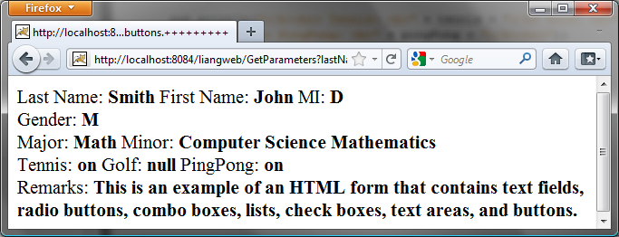
Figure 42.17
The servlet displays the parameter values entered in Figure 42.16.
Listing 42.4 GetParameters.java
<Side Remark line 9: process GET>
<Side Remark line 11: content type>
<Side Remark line 12: output to browser>
<Side Remark line 15: get parameters>
<Side Remark line 20: multiple values>
<Side Remark line 38: close stream>
package chapter42;

import javax.servlet.*;
import javax.servlet.http.*;
import java.io.*;

public class GetParameters extends HttpServlet {
/** Process the HTTP Post request */
public void doGet(HttpServletRequest request, HttpServletResponse
response) throws ServletException, IOException {
response.setContentType("text/html");
PrintWriter out = response.getWriter();

// Obtain parameters from the client
String lastName = request.getParameter("lastName");
String firstName = request.getParameter("firstName");
String mi = request.getParameter("mi");
String gender = request.getParameter("gender");
String major = request.getParameter("major");
String[] minors = request.getParameterValues("minor");
String tennis = request.getParameter("tennis");
String golf = request.getParameter("golf");
String pingPong = request.getParameter("pingPong");
String remarks = request.getParameter("remarks");

out.println("Last Name: <b>" + lastName + "</b> First Name: <b>"
+ firstName + "</b> MI: <b>" + mi + "</b><br>");
out.println("Gender: <b>" + gender + "</b><br>");
out.println("Major: <b>" + major + "</b> Minor: <b>");

if (minors != null)
for (int i = 0; i < minors.length; i++)
out.println(minors[i] + " ");

out.println("</b><br> Tennis: <b>" + tennis + "</b> Golf: <b>" +
golf + "</b> PingPong: <b>" + pingPong + "</b><br>");
out.println("Remarks: <b>" + remarks + "</b>");
out.close(); // Close stream
}
}
The HTML form is already created in StudentRegistrationForm.html and displayed in Figure 42.16. Since the action for the form is HGetParametersH, clicking the Submit button invokes the GetParameters servlet.

Each GUI component in the form has a name attribute. The servlet uses the name attribute in the getParameter(attributeName) method to obtain the parameter value as a string. In case of a list with multiple values, use the getParameterValues(attributeName) method to return the parameter values in an array of strings (line 20).

You may optionally specify the value attribute in a text field, text area, combo box, list, check box, or radio button in an HTML form. For text field and text area, the value attribute specifies a default value to be displayed in the text field and text area. The user can type in new values to replace it. For combo box, list, check box, and radio button, the value attribute specifies the parameter value to be returned from the getParameter and getParameterValues methods. If the value attribute is not specified for a combo box or a list, it returns the selected string from the combo box or the list. If the value attribute is not specified for a radio button or a check box, it returns string on for a checked radio button or a checked check box, and returns null for an unchecked check box.

NOTE: If an attribute does not exist, the getParameter(attributeName) method returns null. If an empty value of the parameter is passed to the servlet, the getParameter(attributeName) method returns a string with an empty value. In this case, the length of the string is 0.

42.6.2 Obtaining Current Time Based on Locale and Time Zone
This example creates a servlet that processes the GET and POST requests. The GET request generates a form that contains a combo box for locale and a combo box for time zone, as shown in Figure 42.18a. The user can choose a locale and a time zone from this form to submit a POST request to obtain the current time based on the locale and time zone, as shown in Figure 42.18b.

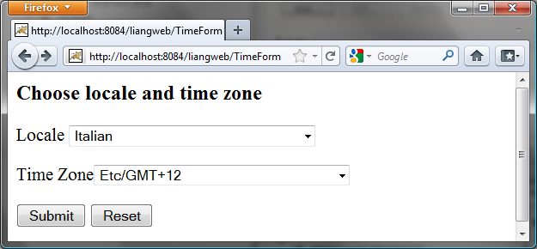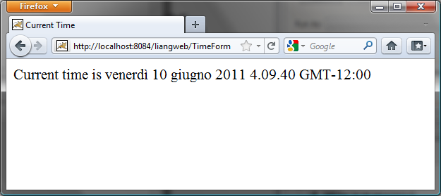
(a) (b)
Figure 42.18
The GET method in the TimeForm servlet displays a form in (a), and the POST method in the TimeForm servlet displays the time based on locale and time zone in (b).
Listing 42.5 gives the servlet.

Listing 42.5 TimeForm.java
<Side Remark line 15: process GET>
<Side Remark line 17: content type>
<Side Remark line 18: output to browser>
<Side Remark line 20: create form>
<Side Remark line 42: close stream>
<Side Remark line 46: process POST>
<Side Remark line 48: content type>
<Side Remark line 49: output to browser>
<Side Remark line 51: get locale>
<Side Remark line 53: get time zone>
<Side Remark line 56: create calendar>
<Side Remark line 65: close stream>
package chapter42;

import javax.servlet.*;
import javax.servlet.http.*;
import java.io.*;
import java.util.*;
import java.text.*;

public class TimeForm extends HttpServlet {
private static final String CONTENT_TYPE = "text/html";
private Locale[] allLocale = Locale.getAvailableLocales();
private String[] allTimeZone = TimeZone.getAvailableIDs();

/** Process the HTTP Get request */
public void doGet(HttpServletRequest request, HttpServletResponse
response) throws ServletException, IOException {
response.setContentType(CONTENT_TYPE);
PrintWriter out = response.getWriter();
out.println("<h3>Choose locale and time zone</h3>");
out.println("<form method=\"post\" action=" +
"TimeForm>");
out.println("Locale <select size=\"1\" name=\"locale\">");

// Fill in all locales
for (int i = 0; i < allLocale.length; i++) {
out.println("<option value=\"" + i +"\">" +
allLocale[i].getDisplayName() + "</option>");
}
out.println("</select>");

// Fill in all time zones
out.println("<p>Time Zone<select size=\"1\" name=\"timezone\">");
for (int i = 0; i < allTimeZone.length; i++) {
out.println("<option value=\"" + allTimeZone[i] +"\">" +
allTimeZone[i] + "</option>");
}
out.println("</select>");

out.println("<p><input type=\"submit\" value=\"Submit\" >");
out.println("<input type=\"reset\" value=\"Reset\"></p>");
out.println("</form>");
out.close(); // Close stream
}

/** Process the HTTP Post request */
public void doPost(HttpServletRequest request, HttpServletResponse
response) throws ServletException, IOException {
response.setContentType(CONTENT_TYPE);
PrintWriter out = response.getWriter();
out.println("<html>");
int localeIndex = Integer.parseInt(
request.getParameter("locale"));
String timeZoneID = request.getParameter("timezone");
out.println("<head><title>Current Time</title></head>");
out.println("<body>");
Calendar calendar =
new GregorianCalendar(allLocale[localeIndex]);
TimeZone timeZone = TimeZone.getTimeZone(timeZoneID);
DateFormat dateFormat = DateFormat.getDateTimeInstance(
DateFormat.FULL, DateFormat.FULL, allLocale[localeIndex]);
dateFormat.setTimeZone(timeZone);
out.println("Current time is " +
dateFormat.format(calendar.getTime()) + "</p>");
out.println("</body></html>");
out.close(); // Close stream
}
}
When you run this servlet, the servlet TimeForm’s doGet method is invoked to generate the time form dynamically. The method of the form is POST, and the action invokes the same servlet, TimeForm. When the form is submitted to the server, the doPost method is invoked to process the request.

The variables allLocale and allTimeZone (lines 11–12), respectively, hold all the available locales and time zone IDs. The names of the locales are displayed in the locale list. The values for the locales are the indexes of the locales in the array allLocale. The time zone IDs are strings. They are displayed in the time zone list. They are also the values for the list. The indexes of the locale and the time zone are passed to the servlet as parameters. The doPost method obtains the values of the parameters (lines 51–53) and finds the current time based on the locale and time zone.

NOTE
<Side Remark: set character encoding>
If you choose an Asian locale (e.g., Chinese, Korean, or Japanese), the time will not be displayed properly, because the default character encoding is UTF-8. To fix this problem, insert the following statement in line 48 to set an international character encoding:
response.setCharacterEncoding("GB18030");

For information on encoding, see §31.6, “Character Encoding.”
***End of NOTE

42.7 Database Programming in Servlets
Many dynamic Web applications use databases to store and manage data. Servlets can connect to any relational database via JDBC. In Chapter 37, “Java Database Programming,” you learned how to create Java programs to access and manipulate relational databases via JDBC. Connecting a servlet to a database is no different from connecting a Java application or applet to a database. If you know Java servlets and JDBC, you can combine them to develop interesting and practical Web-based interactive projects.

To demonstrate connecting to a database from a servlet, let us create a servlet that processes a registration form. The client enters data in an HTML form and submits the form to the server, as shown in Figure 42.19. The result of the submission is shown in Figure 42.20. The server collects the data from the form and stores them in a database.

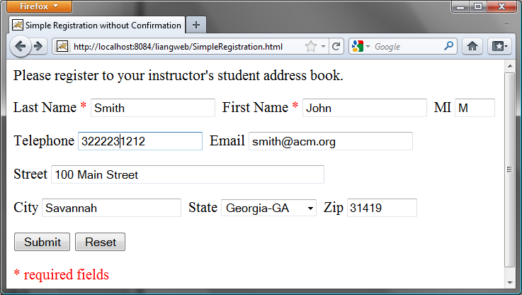
Figure 42.19
The HTML form enables the user to enter student information.
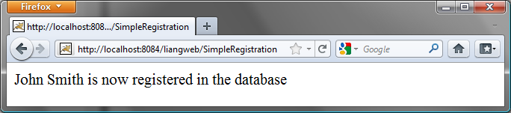
Figure 42.20
The servlet processes the form and stores data in a database.
The registration data are stored in an Address table consisting of the following fields: firstName, mi, lastName, street, city, state, zip, telephone, and email, defined in the following statement:

create table Address (
firstname varchar(25),
mi char(1),
lastname varchar(25),
street varchar(40),
city varchar(20),
state varchar(2),
zip varchar(5),
telephone varchar(10),
email varchar(30)
)
<Side Remark: mysqljdbc.jar>
<Side Remark: ojdbc6.jar>
MySQL, Oracle, and Access were used in Chapter 37. You can use any relational database. If the servlet uses a database driver other than the JDBC-ODBC driver (e.g., the MySQL JDBC driver and the Oracle JDBC driver), you need to add the JDBC driver (e.g., mysqljdbc.jar for MySQL and ojdbc6.jar for Oracle) into the Libraries node in the project.

<Side Remark: place .html file>
Create an HTML file named SimpleRegistration.html in Listing 42.6 for collecting the data and sending them to the database using the post method.

Listing 42.6 SimpleRegistration.html
<Side Remark line 9: action>
<Side Remark line 31: submit form>
<!-- SimpleRegistration.html -->
<html>
<head>
<title>Simple Registration without Confirmation</title>
</head>
<body>
Please register to your instructor's student address book.

<form method = "post" action = "SimpleRegistration">
<p>Last Name <font color = "#FF0000">*</font>
<input type = "text" name = "lastName">&nbsp;
First Name <font color = "#FF0000">*</font>
<input type = "text" name = "firstName">&nbsp;
MI <input type = "text" name = "mi" size = "3">
</p>
<p>Telephone
<input type = "text" name = "telephone" size = "20">&nbsp;
Email
<input type = "text" name = "email" size = "28">&nbsp;
</p>
<p>Street <input type = "text" name = "street" size = "50">
</p>
<p>City <input type = "text" name = "city" size = "23">&nbsp;
State
<select size = "1" name = "state">
<option value = "GA">Georgia-GA</option>
<option value = "OK">Oklahoma-OK</option>
<option value = "IN">Indiana-IN</option>
</select>&nbsp;
Zip <input type = "text" name = "zip" size = "9">
</p>
<p><input type = "submit" name = "Submit" value = "Submit">
<input type = "reset" value = "Reset">
</p>
</form>
<p><font color = "#FF0000">* required fields</font></p>
</body>
</html>

<Side Remark: place .class file>
Create the servlet named SimpleRegistration in Listing 42.7.

Listing 42.7 SimpleRegistration.java
<Side Remark line 14: initialize db>
<Side Remark line 18: process POST>
<Side Remark line 20: content type>
<Side Remark line 21: output to browser>
<Side Remark line 24: get parameters>
<Side Remark line 39: store record>
<Side Remark line 50: close stream>
<Side Remark line 58: connect db>
<Side Remark line 63: prepare statement>
<Side Remark line 76: set values>
<Side Remark line 85: execute SQL>
package chapter42;

import javax.servlet.*;
import javax.servlet.http.*;
import java.io.*;
import java.sql.*;

public class SimpleRegistration extends HttpServlet {
// Use a prepared statement to store a student into the database
private PreparedStatement pstmt;

/** Initialize variables */
public void init() throws ServletException {
initializeJdbc();
}

/** Process the HTTP Post request */
public void doPost(HttpServletRequest request, HttpServletResponse
response) throws ServletException, IOException {
response.setContentType("text/html");
PrintWriter out = response.getWriter();

// Obtain parameters from the client
String lastName = request.getParameter("lastName");
String firstName = request.getParameter("firstName");
String mi = request.getParameter("mi");
String phone = request.getParameter("telephone");
String email = request.getParameter("email");
String address = request.getParameter("street");
String city = request.getParameter("city");
String state = request.getParameter("state");
String zip = request.getParameter("zip");

try {
if (lastName.length() == 0 || firstName.length() == 0) {
out.println("Last Name and First Name are required");
}
else {
storeStudent(lastName, firstName, mi, phone, email,
address, city, state, zip);

out.println(firstName + " " + lastName +
" is now registered in the database");
}
}
catch(Exception ex) {
out.println("Error: " + ex.getMessage());
}
finally {
out.close(); // Close stream
}
}

/** Initialize database connection */
private void initializeJdbc() {
try {
// Load the JDBC driver
Class.forName("com.mysql.jdbc.Driver");
System.out.println("Driver loaded");

// Establish a connection
Connection conn = DriverManager.getConnection
("jdbc:mysql://localhost/javabook" , "scott", "tiger");
System.out.println("Database connected");

// Create a Statement
pstmt = conn.prepareStatement("insert into Address " +
"(lastName, firstName, mi, telephone, email, street, city, "
+ "state, zip) values (?, ?, ?, ?, ?, ?, ?, ?, ?)");
}
catch (Exception ex) {
ex.printStackTrace();
}
}

/** Store a student record to the database */
private void storeStudent(String lastName, String firstName,
String mi, String phone, String email, String address,
String city, String state, String zip) throws SQLException {
pstmt.setString(1, lastName);
pstmt.setString(2, firstName);
pstmt.setString(3, mi);
pstmt.setString(4, phone);
pstmt.setString(5, email);
pstmt.setString(6, address);
pstmt.setString(7, city);
pstmt.setString(8, state);
pstmt.setString(9, zip);
pstmt.executeUpdate();
}
}
The init method (line 13) is executed once when the servlet starts. After the servlet has started, the servlet can be invoked many times as long as it is alive in the servlet container. Load the driver and connect to the database from the servlet’s init method (line 14). If a prepared statement or a callable statement is used, it should also be created in the init method. In this example, a prepared statement is desirable, because the servlet always uses the same insert statement with different values.

A servlet can connect to any relational database via JDBC. The initializeJdbc method in this example connects to a MySQL database (line 58). Once connected, it creates a prepared statement for inserting a student record into the database. MySQL is used in this example; you can replace it with any relational database.

Last name and first name are required fields. If either of them is empty, the servlet sends an error message to the client (lines 35–36). Otherwise, the servlet stores the data in the database using the prepared statement.

42.8 Session Tracking
Web servers use the Hyper-Text Transport Protocol (HTTP). HTTP is a stateless protocol. An HTTP Web server cannot associate requests from a client, and therefore treats each request independently. This protocol works fine for simple Web browsing, where each request typically results in an HTML file or a text file being sent back to the client. Such simple requests are isolated. However, the requests in interactive Web applications are often related. Consider the two requests in the following scenario:

Request 1: A client sends registration data to the server; the server then returns the data to the user for confirmation.
Request 2: The client confirms the data that was submitted in Request 1.
In Request 2, the data submitted in Request 1 are confirmed. These two requests are related in a session. A session can be defined as a series of related interactions between a single client and the Web server over a period of time. Tracking data among requests in a session is known as session tracking.

This section introduces three techniques for session tracking: using hidden values, using cookies, and using the session tracking tools from servlet API.

42.8.1 Session Tracking Using Hidden Values
You can track a session by passing data from the servlet to the client as hidden values in a dynamically generated HTML form by including a field like this one:

<input type = "hidden" name = "lastName" value = "Smith">

The next request will submit the data back to the servlet. The servlet retrieves this hidden value just like any other parameter value, using the getParameter method.

Let us use an example to demonstrate using hidden values in a form. The example creates a servlet that processes a registration form. The client submits the form using the GET method, as shown in Figure 42.21. The server collects the data in the form, displays them to the client, and asks the client for confirmation, as shown in Figure 42.22. The client confirms the data by submitting the request with the hidden values using the POST method. Finally, the servlet writes the data to a database.

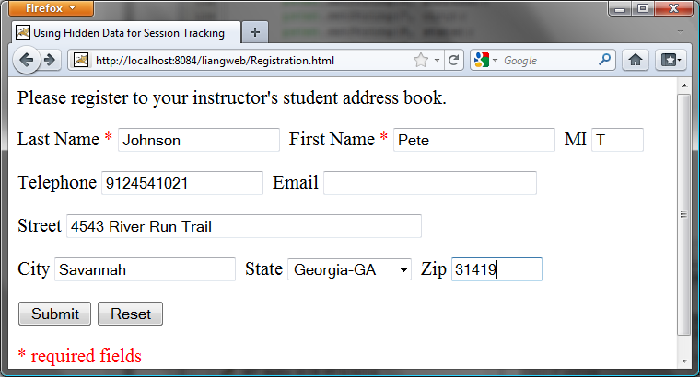
Figure 42.21
The registration form collects user information.
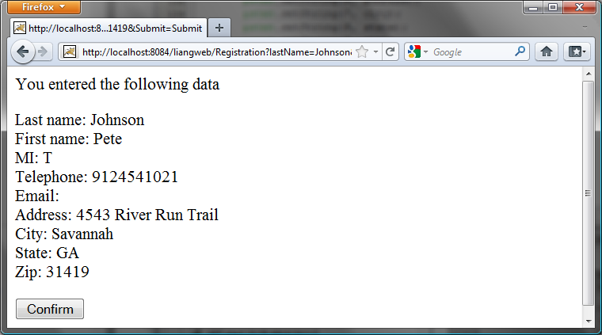
Figure 42.22
The servlet asks the client for confirmation of the input.
Create an HTML form named Registration.html in Listing 42.8 for collecting the data and sending it to the database using the GET method for confirmation. This file is almost identical to Listing 42.6, SimpleRegistration.html except that the action is replaced by Registration (line 9).

Listing 42.8 Registration.html
<Side Remark line 9: action>
<Side Remark line 32: submit form>
<!-- Registration.html -->
<html>
<head>
<title>Using Hidden Data for Session Tracking</title>
</head>
<body>
Please register to your instructor's student address book.

<form method = "get" action = "Registration">
<p>Last Name <font color = "#FF0000">*</font>
<input type = "text" name = "lastName">&nbsp;
First Name <font color = "#FF0000">*</font>
<input type = "text" name = "firstName">&nbsp;
MI <input type = "text" name = "mi" size = "3">
</p>
<p>Telephone
<input type = "text" name = "telephone" size = "20">&nbsp;
Email
<input type = "text" name = "email" size = "28">&nbsp;
</p>
<p>Street <input type = "text" name = "street" size = "50">
</p>
<p>City <input type = "text" name = "city" size = "23">&nbsp;
State
<select size = "1" name = "state">
<option value = "GA">Georgia-GA</option>
<option value = "OK">Oklahoma-OK</option>
<option value = "IN">Indiana-IN</option>
</select>&nbsp;
Zip <input type = "text" name = "zip" size = "9">
</p>
<p><input type = "submit" name = "Submit" value = "Submit">
<input type = "reset" value = "Reset">
</p>
</form>
<p><font color = "#FF0000">* required fields</font></p>
</body>
</html>

Create the servlet named Registration in Listing 42.9.

Listing 42.9 Registration.java
<Side Remark line 14: initialize db>
<Side Remark line 18: process GET>
<Side Remark line 20: content type>
<Side Remark line 21: output to browser>
<Side Remark line 24: get parameters>
<Side Remark line 51: client verification>
<Side Remark line 80: process POST>
<Side Remark line 82: content type>
<Side Remark line 83: output to browser>
<Side Remark line 86: get parameters>
<Side Remark line 126: store record>
package chapter42;

import javax.servlet.*;
import javax.servlet.http.*;
import java.io.*;
import java.sql.*;

public class Registration extends HttpServlet {
// Use a prepared statement to store a student into the database
private PreparedStatement pstmt;

/** Initialize variables */
public void init() throws ServletException {
initializeJdbc();
}

/** Process the HTTP Get request */
public void doGet(HttpServletRequest request, HttpServletResponse
response) throws ServletException, IOException {
response.setContentType("text/html");
PrintWriter out = response.getWriter();

// Obtain data from the form
String lastName = request.getParameter("lastName");
String firstName = request.getParameter("firstName");
String mi = request.getParameter("mi");
String telephone = request.getParameter("telephone");
String email = request.getParameter("email");
String street = request.getParameter("street");
String city = request.getParameter("city");
String state = request.getParameter("state");
String zip = request.getParameter("zip");

if (lastName.length() == 0 || firstName.length() == 0) {
out.println("Last Name and First Name are required");
}
else {
// Ask for confirmation
out.println("You entered the following data");
out.println("<p>Last name: " + lastName);
out.println("<br>First name: " + firstName);
out.println("<br>MI: " + mi);
out.println("<br>Telephone: " + telephone);
out.println("<br>Email: " + email);
out.println("<br>Address: " + street);
out.println("<br>City: " + city);
out.println("<br>State: " + state);
out.println("<br>Zip: " + zip);

// Set the action for processing the answers
out.println("<p><form method=\"post\" action=" +
"Registration>");
// Set hidden values
out.println("<p><input type=\"hidden\" " +
"value=" + lastName + " name=\"lastName\">");
out.println("<p><input type=\"hidden\" " +
"value=" + firstName + " name=\"firstName\">");
out.println("<p><input type=\"hidden\" " +
"value=" + mi + " name=\"mi\">");
out.println("<p><input type=\"hidden\" " +
"value=" + telephone + " name=\"telephone\">");
out.println("<p><input type=\"hidden\" " +
"value=" + email + " name=\"email\">");
out.println("<p><input type=\"hidden\" " +
"value=" + street + " name=\"street\">");
out.println("<p><input type=\"hidden\" " +
"value=" + city + " name=\"city\">");
out.println("<p><input type=\"hidden\" " +
"value=" + state + " name=\"state\">");
out.println("<p><input type=\"hidden\" " +
"value=" + zip + " name=\"zip\">");
out.println("<p><input type=\"submit\" value=\"Confirm\" >");
out.println("</form>");
}

out.close(); // Close stream
}

/** Process the HTTP Post request */
public void doPost(HttpServletRequest request, HttpServletResponse
response) throws ServletException, IOException {
response.setContentType("text/html");
PrintWriter out = response.getWriter();

try {
String lastName = request.getParameter("lastName");
String firstName = request.getParameter("firstName");
String mi = request.getParameter("mi");
String telephone = request.getParameter("telephone");
String email = request.getParameter("email");
String street = request.getParameter("street");
String city = request.getParameter("city");
String state = request.getParameter("state");
String zip = request.getParameter("zip");

storeStudent(lastName, firstName, mi, telephone, email,
street, city, state, zip);

out.println(firstName + " " + lastName +
" is now registered in the database");
}
catch(Exception ex) {
out.println("Error: " + ex.getMessage());
}
}

/** Initialize database connection */
private void initializeJdbc() {
try {
// Load the JDBC driver
Class.forName("com.mysql.jdbc.Driver");
System.out.println("Driver loaded");

// Establish a connection
Connection conn = DriverManager.getConnection
("jdbc:mysql://localhost/javabook" , "scott", "tiger");
System.out.println("Database connected");

// Create a Statement
pstmt = conn.prepareStatement("insert into Address " +
"(lastName, firstName, mi, telephone, email, street, city, "
+ "state, zip) values (?, ?, ?, ?, ?, ?, ?, ?, ?)");
}
catch (Exception ex) {
System.out.println(ex);
}
}

/** Store a student record to the database */
private void storeStudent(String lastName, String firstName,
String mi, String phone, String email, String address,
String city, String state, String zip) throws SQLException {
pstmt.setString(1, lastName);
pstmt.setString(2, firstName);
pstmt.setString(3, mi);
pstmt.setString(4, phone);
pstmt.setString(5, email);
pstmt.setString(6, address);
pstmt.setString(7, city);
pstmt.setString(8, state);
pstmt.setString(9, zip);
pstmt.executeUpdate();
}
}

The servlet processes the GET request by generating an HTML page that displays the client’s input and asks for the client’s confirmation. The input data consist of hidden values in the newly generated forms, so they will be sent back in the confirmation request. The confirmation request uses the POST method. The servlet retrieves the hidden values and stores them in the database.

Since the first request does not write anything to the database, it is appropriate to use the GET method. Since the second request results in an update to the database, the POST method must be used.

NOTE: The hidden values could also be sent from the URL query string if the request used the GET method.

42.8.2 Session Tracking Using Cookies
You can track sessions using cookies, which are small text files that store sets of name/value pairs on the disk in the client’s computer. Cookies are sent from the server through the instructions in the header of the HTTP response. The instructions tell the browser to create a cookie with a given name and its associated value. If the browser already has a cookie with the key name, the value will be updated. The browser will then send the cookie with any request submitted to the same server. Cookies can have expiration dates set, after which they will not be sent to the server. The javax.servlet.http.Cookie is used to create and manipulate cookies, as shown in Figure 42.23.

<PD: UML Class Diagram>
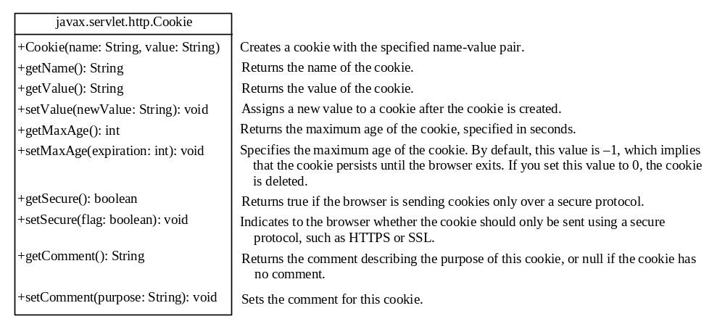

Figure 42.23
Cookie stores a name/value pair and other information about the cookie.
To send a cookie to the browser, use the addCookie method in the HttpServletResponse class, as shown below:

response.addCookie(cookie);

where response is an instance of HttpServletResponse.

To obtain cookies from a browser, use
request.getCookies();

where request is an instance of HttpServletRequest.

To demonstrate the use of cookies, let us create an example that accomplishes the same task as Listing 42.9, Registration.java. Instead of using hidden values for session tracking, it uses cookies.

Create the servlet named RegistrationWithHttpCookie in Listing 42.10. Create an HTML file named RegistrationWithCookie.html that is identical to Registration.html except that the action is replaced by RegistrationWithCookieH..

Listing 42.10 RegistrationWithCookie.java
<Side Remark line 19: process GET>
<Side Remark line 25: get parameters>
<Side Remark line 40: create cookies>
<Side Remark line 42: add cookies>
<Side Remark line 62: client verification>
<Side Remark line 84: process POST>
<Side Remark line 100: get cookies>
<Side Remark line 125: store record>
package chapter42;

import javax.servlet.*;
import javax.servlet.http.*;
import java.io.*;
import java.sql.*;

public class RegistrationWithCookie extends HttpServlet {
private static final String CONTENT_TYPE = "text/html";
// Use a prepared statement to store a student into the database
private PreparedStatement pstmt;

/** Initialize variables */
public void init() throws ServletException {
initializeJdbc();
}

/** Process the HTTP Get request */
public void doGet(HttpServletRequest request, HttpServletResponse
response) throws ServletException, IOException {
response.setContentType("text/html");
PrintWriter out = response.getWriter();

// Obtain data from the form
String lastName = request.getParameter("lastName");
String firstName = request.getParameter("firstName");
String mi = request.getParameter("mi");
String telephone = request.getParameter("telephone");
String email = request.getParameter("email");
String street = request.getParameter("street");
String city = request.getParameter("city");
String state = request.getParameter("state");
String zip = request.getParameter("zip");

if (lastName.length() == 0 || firstName.length() == 0) {
out.println("Last Name and First Name are required");
}
else {
// Create cookies and send cookies to browsers
Cookie cookieLastName = new Cookie("lastName", lastName);
// cookieLastName.setMaxAge(1000);
response.addCookie(cookieLastName);
Cookie cookieFirstName = new Cookie("firstName", firstName);
response.addCookie(cookieFirstName);
// cookieFirstName.setMaxAge(0);
Cookie cookieMi = new Cookie("mi", mi);
response.addCookie(cookieMi);
Cookie cookieTelephone = new Cookie("telephone", telephone);
response.addCookie(cookieTelephone);
Cookie cookieEmail = new Cookie("email", email);
response.addCookie(cookieEmail);
Cookie cookieStreet = new Cookie("street", street);
response.addCookie(cookieStreet);
Cookie cookieCity = new Cookie("city", city);
response.addCookie(cookieCity);
Cookie cookieState = new Cookie("state", state);
response.addCookie(cookieState);
Cookie cookieZip = new Cookie("zip", zip);
response.addCookie(cookieZip);

// Ask for confirmation
out.println("You entered the following data");
out.println("<p>Last name: " + lastName);
out.println("<br>First name: " + firstName);
out.println("<br>MI: " + mi);
out.println("<br>Telephone: " + telephone);
out.println("<br>Email: " + email);
out.println("<br>Street: " + street);
out.println("<br>City: " + city);
out.println("<br>State: " + state);
out.println("<br>Zip: " + zip);

// Set the action for processing the answers
out.println("<p><form method=\"post\" action=" +
"RegistrationWithCookie>");
out.println("<p><input type=\"submit\" value=\"Confirm\" >");
out.println("</form>");
}

out.close(); // Close stream
}

/** Process the HTTP Post request */
public void doPost(HttpServletRequest request, HttpServletResponse
response) throws ServletException, IOException {
response.setContentType(CONTENT_TYPE);
PrintWriter out = response.getWriter();

String lastName = "";
String firstName = "";
String mi = "";
String telephone = "";
String email = "";
String street = "";
String city = "";
String state = "";
String zip = "";

// Read the cookies
Cookie[] cookies = request.getCookies();

// Get cookie values
for (int i = 0; i < cookies.length; i++) {
if (cookies[i].getName().equals("lastName"))
lastName = cookies[i].getValue();
else if (cookies[i].getName().equals("firstName"))
firstName = cookies[i].getValue();
else if (cookies[i].getName().equals("mi"))
mi = cookies[i].getValue();
else if (cookies[i].getName().equals("telephone"))
telephone = cookies[i].getValue();
else if (cookies[i].getName().equals("email"))
email = cookies[i].getValue();
else if (cookies[i].getName().equals("street"))
street = cookies[i].getValue();
else if (cookies[i].getName().equals("city"))
city = cookies[i].getValue();
else if (cookies[i].getName().equals("state"))
state = cookies[i].getValue();
else if (cookies[i].getName().equals("zip"))
zip = cookies[i].getValue();
}

try {
storeStudent(lastName, firstName, mi, telephone, email, street,
city, state, zip);

out.println(firstName + " " + lastName +
" is now registered in the database");

out.close(); // Close stream
}
catch(Exception ex) {
out.println("Error: " + ex.getMessage());
}
}

/** Initialize database connection */
private void initializeJdbc() {
try {
// Load the JDBC driver
Class.forName("com.mysql.jdbc.Driver");
System.out.println("Driver loaded");

// Establish a connection
Connection conn = DriverManager.getConnection
("jdbc:mysql://localhost/javabook" , "scott", "tiger");
System.out.println("Database connected");

// Create a Statement
pstmt = conn.prepareStatement("insert into Address " +
"(lastName, firstName, mi, telephone, email, street, city, "
+ "state, zip) values (?, ?, ?, ?, ?, ?, ?, ?, ?)");
}
catch (Exception ex) {
System.out.println(ex);
}
}

/** Store a student record to the database */
private void storeStudent(String lastName, String firstName,
String mi, String telephone, String email, String street,
String city, String state, String zip) throws SQLException {
pstmt.setString(1, lastName);
pstmt.setString(2, firstName);
pstmt.setString(3, mi);
pstmt.setString(4, telephone);
pstmt.setString(5, email);
pstmt.setString(6, street);
pstmt.setString(7, city);
pstmt.setString(8, state);
pstmt.setString(9, zip);
pstmt.executeUpdate();
}
}
You have to create a cookie for each value you want to track, using the Cookie class’s only constructor, which defines a cookie’s name and value as shown below (line 40):

Cookie cookieLastName = new Cookie("lastName", lastName);

To send the cookie to the browser, use a statement like this one (line 42):

response.addCookie(cookieLastName);

If a cookie with the same name already exists in the browser, its value is updated; otherwise, a new cookie is created.

Cookies are automatically sent to the Web server with each request from the client. The servlet retrieves all the cookies into an array using the getCookies method (line 100):
Cookie[] cookies = request.getCookies();

To obtain the name of the cookie, use the getName method (line 104):

String name = cookies[i].getName();

The cookie’s value can be obtained using the getValue method:

String value = cookies[i].getValue();

Cookies are stored as strings just like form parameters and hidden values. If a cookie represents a numeric value, you have to convert it into an integer or a double, using the parseInt method in the Integer class or the parseDouble method in the Double class.

By default, a newly created cookie persists until the browser exits. However, you can set an expiration date, using the setMaxAge method, to allow a cookie to stay in the browser for up to 2,147,483,647 seconds (approximately 24,855 days).

42.8.3 Session Tracking Using the Servlet API
You have now learned both session tracking using hidden values and session tracking using cookies. These two session-tracking methods have problems. They send data to the browser either as hidden values or as cookies. The data are not secure, and anybody with knowledge of computers can obtain them. The hidden data are in HTML form, which can be viewed from the browser. Cookies are stored in the Cache directory of the browser. Because of security concerns, some browsers do not accept cookies. The client can turn the cookies off and limit their number. Another problem is that hidden data and cookies pass data as strings. You cannot pass objects using these two methods.

To address these problems, Java servlet API provides the javax.servlet.http.HttpSession interface, which provides a way to identify a user across more than one page request or visit to a Web site and to store information about that user. The servlet container uses this interface to create a session between an HTTP client and an HTTP server. The session persists for a specified time period, across more than one connection or page request from the user. A session usually corresponds to one user, who may visit a site many times. The session enables tracking of a large set of data. The data can be stored as objects and are secure because they are kept on the server side.

To use the Java servlet API for session tracking, first create a session object using the getSession() method in the HttpServletRequest interface:
HttpSession session = request.getSession();

This obtains the session or creates a new session if the client does not have a session on the server.

The HttpSession interface provides the methods for reading and storing data to the session, and for manipulating the session, as shown in Figure 42.24.

<PD: UML Class Diagram>
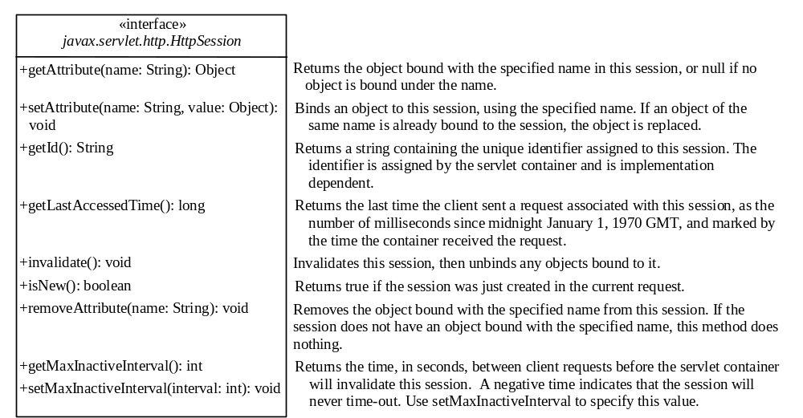

Figure 42.24
HttpSession establishes a persistent session between a client with multiple requests and the server.
NOTE: HTTP is stateless. So how does the server associate a session with multiple requests from the same client? This is handled behind the scenes by the servlet container and is transparent to the servlet programmer.
To demonstrate using HttpSession, let us rewrite Listing 42.9, Registration.java, and Listing 42.10, RegistrationWithCookie.java. Instead of using hidden values or cookies for session tracking, it uses servlet HttpSession.

Create the servlet named RegistrationWithHttpSession in Listing 42.11. Create an HTML file named RegistrationWithHttpSession.html that is identical to Registration.html except that the action is replaced by RegistrationWithHttpSessionH.

Listing 42.11 RegistrationWithHttpSession.java
<Side Remark line 18: process GET>
<Side Remark line 25: get parameters>
<Side Remark line 40: create address>
<Side Remark line 52: create session>
<Side Remark line 55: set attribute>
<Side Remark line 80: process POST>
<Side Remark line 87: get session>
<Side Remark line 90: get address>
<Side Remark line 93: store address>

package chapter42;

import javax.servlet.*;
import javax.servlet.http.*;
import java.io.*;
import java.sql.*;

public class RegistrationWithHttpSession extends HttpServlet {
// Use a prepared statement to store a student into the database
private PreparedStatement pstmt;

/** Initialize variables */
public void init() throws ServletException {
initializeJdbc();
}

/** Process the HTTP Get request */
public void doGet(HttpServletRequest request, HttpServletResponse
response) throws ServletException, IOException {
// Set response type and output stream to the browser
response.setContentType("text/html");
PrintWriter out = response.getWriter();

// Obtain data from the form
String lastName = request.getParameter("lastName");
String firstName = request.getParameter("firstName");
String mi = request.getParameter("mi");
String telephone = request.getParameter("telephone");
String email = request.getParameter("email");
String street = request.getParameter("street");
String city = request.getParameter("city");
String state = request.getParameter("state");
String zip = request.getParameter("zip");

if (lastName.length() == 0 || firstName.length() == 0) {
out.println("Last Name and First Name are required");
}
else {
// Create an Address object
Address address = new Address();
address.setLastName(lastName);
address.setFirstName(firstName);
address.setMi(mi);
address.setTelephone(telephone);
address.setEmail(email);
address.setStreet(street);
address.setCity(city);
address.setState(state);
address.setZip(zip);

// Get an HttpSession or create one if it does not exist
HttpSession httpSession = request.getSession();

// Store student object to the session
httpSession.setAttribute("address", address);

// Ask for confirmation
out.println("You entered the following data");
out.println("<p>Last name: " + lastName);
out.println("<p>First name: " + firstName);
out.println("<p>MI: " + mi);
out.println("<p>Telephone: " + telephone);
out.println("<p>Email: " + email);
out.println("<p>Address: " + street);
out.println("<p>City: " + city);
out.println("<p>State: " + state);
out.println("<p>Zip: " + zip);

// Set the action for processing the answers
out.println("<p><form method=\"post\" action=" +
"RegistrationWithHttpSession>");
out.println("<p><input type=\"submit\" value=\"Confirm\" >");
out.println("</form>");
}

out.close(); // Close stream
}

/** Process the HTTP Post request */
public void doPost(HttpServletRequest request, HttpServletResponse
response) throws ServletException, IOException {
// Set response type and output stream to the browser
response.setContentType("text/html");
PrintWriter out = response.getWriter();

// Obtain the HttpSession
HttpSession httpSession = request.getSession();

// Get the Address object in the HttpSession
Address address = (Address)(httpSession.getAttribute("address"));

try {
storeStudent(address);

out.println(address.getFirstName() + " " + address.getLastName()
+ " is now registered in the database");
out.close(); // Close stream
}
catch(Exception ex) {
out.println("Error: " + ex.getMessage());
}
}

/** Initialize database connection */
private void initializeJdbc() {
try {
// Load the JDBC driver
Class.forName("com.mysql.jdbc.Driver");
System.out.println("Driver loaded");

// Establish a connection
Connection conn = DriverManager.getConnection
("jdbc:mysql://localhost/javabook" , "scott", "tiger");
System.out.println("Database connected");

// Create a Statement
pstmt = conn.prepareStatement("insert into Address " +
"(lastName, firstName, mi, telephone, email, street, city, "
+ "state, zip) values (?, ?, ?, ?, ?, ?, ?, ?, ?)");
}
catch (Exception ex) {
System.out.println(ex);
}
}

/** Store an address to the database */
private void storeStudent(Address address) throws SQLException {
pstmt.setString(1, address.getLastName());
pstmt.setString(2, address.getFirstName());
pstmt.setString(3, address.getMi());
pstmt.setString(4, address.getTelephone());
pstmt.setString(5, address.getEmail());
pstmt.setString(6, address.getStreet());
pstmt.setString(7, address.getCity());
pstmt.setString(8, address.getState());
pstmt.setString(9, address.getZip());
pstmt.executeUpdate();
}
}

The statement (line 52)

HttpSession httpSession = request.getSession();

obtains a session, or creates a new session if the session does not exist.

Since objects can be stored in HttpSession, this program defines an Address class. An Address object is created and is stored in the session using the setAttribute method, which binds the object with a name like the one shown below (line 55):
httpSession.setAttribute("address", address);

To retrieve the object, use the following statement (line 90):
Address address = (Address)(httpSession.getAttribute("address"));

There is only one session between a client and a servlet. You can store any number of objects in a session. By default, the maximum inactive interval on many Web servers including Tomcat and GlassFish is 1800 seconds (i.e., a half-hour), meaning that the session expires if there is no activity for 30 minutes. You can change the default using the setMaxInactiveInterval method. For example, to set the maximum inactive interval to one hour, use

httpSession.setMaxInactiveInterval(3600);

If you set a negative value, the session will never expire.

<Side Remark: create Address class>
For this servlet program to work, you have to create the Address class in NetBeans, as follows:

- Choose New, Java Class from the context menu of the liangweb node in the project pane to display the New Java Class dialog box.
- Enter Address as the Class Name and chapter42 as the package name. Click Finish to create the class.
- Enter the code, as shown in Listing 42.12.

Listing 42.12 Address.java
<Side Remark line 1: package chapter42>
<Side Remark line 3: class Address>
package chapter42;

public class Address {
private String firstName;
private String mi;
private String lastName;
private String telephone;
private String street;
private String city;
private String state;
private String email;
private String zip;

public String getFirstName() {
return this.firstName;
}

public void setFirstName(String firstName) {
this.firstName = firstName;
}

public String getMi() {
return this.mi;
}

public void setMi(String mi) {
this.mi = mi;
}

public String getLastName() {
return this.lastName;
}

public void setLastName(String lastName) {
this.lastName = lastName;
}

public String getTelephone() {
return this.telephone;
}

public void setTelephone(String telephone) {
this.telephone = telephone;
}

public String getEmail() {
return this.email;
}

public void setEmail(String email) {
this.email = email;
}

public String getStreet() {
return this.street;
}

public void setStreet(String street) {
this.street = street;
}

public String getCity() {
return this.city;
}

public void setCity(String city) {
this.city = city;
}

public String getState() {
return this.state;
}

public void setState(String state) {
this.state = state;
}

public String getZip() {
return this.zip;
}

public void setZip(String zip) {
this.zip = zip;
}
}

This support class will also be reused in the upcoming chapters.

42.9 Sending Images from Servlets
So far you have learned how to write Java servlets that generate dynamic HTML text. Java servlets are not limited to sending text to a browser. They can return images on demand. The images can be stored in files or created from programs.

42.9.1 Sending Image from Files
You can use the HTML <img> tag to send images from files. The syntax for the tag is:

<img src = URL alt = text align = [top | middle | bottom | texttop]>

The attribute src specifies the source of the image. The attribute alt specifies an alternative text to be displayed in case the image cannot be displayed on the browser. The attribute align tells the browser where to place the image.

To demonstrate getting images from a file in a servlet, let us create a servlet that dynamically generates the flag of a country and a text that describes the flag, as shown in Figure 42.25. The flag is stored in an image file, and the text that describes the flag is stored in a text file.

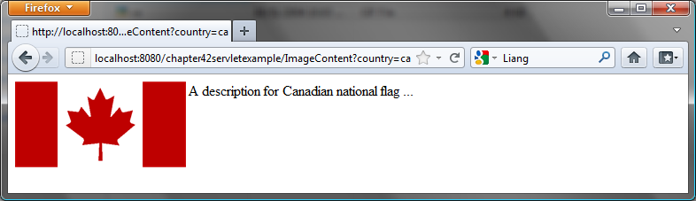
Figure 42.25
The servlet returns an image along with the text.
Create the servlet named ImageContent in Listing 42.13.

Listing 42.13 ImageContent.java
<Side Remark line 16: image tag>
<Side Remark line 20: read file>
package chapter42;

import javax.servlet.*;
import javax.servlet.http.*;
import java.io.*;

public class ImageContent extends HttpServlet {
/** Process the HTTP Get request */
public void doGet(HttpServletRequest request, HttpServletResponse
response) throws ServletException, IOException {
response.setContentType("text/html");
PrintWriter out = response.getWriter();

String country = request.getParameter("country");

out.println("<img src = \"resources/image/" + country + ".gif"
+ "\" align=left>");

// Read description from a file and send it to the browser
java.util.Scanner input = new java.util.Scanner(
new File("c:\\book\\" + country + ".txt"));

// Read a line from the text file and send it to the browser
while (input.hasNext()) {
out.println(input.nextLine());
}

out.close();
}
}
<Side Remark: image file location>
You should create a directory C:\book\liangweb\web\resources\image and store image files in this directory.

The country parameter determines which image file and text file are displayed. The servlet sends the HTML contents to the browser. The contents contain an <img> tag (lines 16–17) that references to the image file.

The servlet reads the characters from the text file and sends them to the browser (lines 20–26).

42.9.2 Sending Images from the Image Object
The preceding example displays an image stored in an image file. You can also display an image dynamically created in the program.

Before the image is sent to a browser, it must be encoded into a format acceptable to the browser. Image encoders are not part of Java API, but several free encoders are available. One of them is the GifEncoder class (http://www.acme.com/java/software/Acme.JPM.Encoders.GifEncoder.html), which is included in \book\lib\acme.jar. Use the following statement to encode and send the image to the browser:

new GifEncoder(image, out, true).encode();

where out is a binary output stream from the servlet to the browser, which can be obtained using the following statement:

OutputStream out = response.getOutputStream();

To demonstrate dynamically generating images from a servlet, let us create a servlet that displays a clock to show the current time, as shown in Figure 42.26.

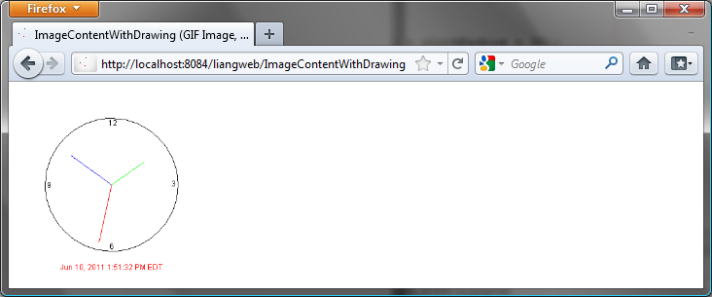
Figure 42.26
The servlet returns a clock that displays the current time.
<Side Remark: acme.jar>
Create the servlet named ImageContentWithDrawing in Listing 42.14. Add acme.jar in the Libraries node in the liangweb project in NetBeans. (acme.jar is in c:\book\lib.)

Listing 42.14 ImageContentWithDrawing.java
<Side Remark line 10: import GifEncoder>
<Side Remark line 18: process GET>
<Side Remark line 20: gif type>
<Side Remark line 24: image>
<Side Remark line 28: graphics>
<Side Remark line 30: draw graphics>
<Side Remark line 35: close stream>
<Side Remark line 38: draw clock>
package chapter42;

import javax.servlet.*;
import javax.servlet.http.*;
import java.io.*;
import java.util.*;
import java.text.*;
import java.awt.*;
import java.awt.image.BufferedImage;
import Acme.JPM.Encoders.GifEncoder;

public class ImageContentWithDrawing extends HttpServlet {
/** Initialize variables */
private final static int width = 300;
private final static int height = 300;

/** Process the HTTP Get request */
public void doGet(HttpServletRequest request, HttpServletResponse
response) throws ServletException, IOException {
response.setContentType("image/gif");
OutputStream out = response.getOutputStream();

// Create image
Image image = new BufferedImage(width, height,
BufferedImage.TYPE_INT_ARGB);

// Get Graphics context of the image
Graphics g = image.getGraphics();

drawClock(g); // Draw a clock on graphics

// Encode the image and send to the output stream
new GifEncoder(image, out, true).encode();

out.close(); // Close stream
}

private void drawClock(Graphics g) {
// Initialize clock parameters
int clockRadius =
(int)(Math.min(width, height) * 0.7 * 0.5);
int xCenter = (width) / 2;
int yCenter = (height) / 2;

// Draw circle
g.setColor(Color.black);
g.drawOval(xCenter - clockRadius,yCenter - clockRadius,
2 * clockRadius, 2 * clockRadius);
g.drawString("12", xCenter - 5, yCenter – clockRadius + 12);
g.drawString("9", xCenter – clockRadius + 3, yCenter + 5);
g.drawString("3", xCenter + clockRadius - 10, yCenter + 3);
g.drawString("6", xCenter - 3, yCenter + clockRadius - 3);

// Get current time using GregorianCalendar
TimeZone timeZone = TimeZone.getDefault();
GregorianCalendar cal = new GregorianCalendar(timeZone);

// Draw second hand
int second = (int)cal.get(GregorianCalendar.SECOND);
int sLength = (int)(clockRadius * 0.9);
int xSecond = (int)(xCenter + sLength * Math.sin(second *
(2 * Math.PI / 60)));
int ySecond = (int)(yCenter – sLength * Math.cos(second *
(2 * Math.PI / 60)));
g.setColor(Color.red);
g.drawLine(xCenter, yCenter, xSecond, ySecond);

// Draw minute hand
int minute = (int)cal.get(GregorianCalendar.MINUTE);
int mLength = (int)(clockRadius * 0.75);
int xMinute = (int)(xCenter + mLength * Math.sin(minute *
(2 * Math.PI / 60)));
int yMinute = (int)(yCenter – mLength * Math.cos(minute *
(2 * Math.PI / 60)));
g.setColor(Color.blue);
g.drawLine(xCenter, yCenter, xMinute, yMinute);

// Draw hour hand
int hour = (int)cal.get(GregorianCalendar.HOUR_OF_DAY);
int hLength = (int)(clockRadius * 0.6);
int xHour = (int)(xCenter + hLength * Math.sin((hour + minute
/ 60.0) * (2 * Math.PI / 12)));
int yHour = (int)(yCenter – hLength * Math.cos((hour + minute
/ 60.0) * (2 * Math.PI / 12)));
g.setColor(Color.green);
g.drawLine(xCenter, yCenter, xHour, yHour);

// Set display format in specified style, locale and time zone
DateFormat formatter = DateFormat.getDateTimeInstance
(DateFormat.MEDIUM, DateFormat.LONG);

// Display current date
g.setColor(Color.red);
String today = formatter.format(cal.getTime());
FontMetrics fm = g.getFontMetrics();
g.drawString(today, (width -
fm.stringWidth(today)) / 2, yCenter + clockRadius + 30);
}
}
Since the image is sent to the browser as binary data, the content type of the response is set to image/gif (line 20). The GifEncoder class is used to encode the image into content understood by the browser (line 33). The content is sent to the OutputStream object out.

The program creates an image with the specified width, height, and image type, using the BufferedImage class (lines 24–25):

Image image = new BufferedImage(width, height,
BufferedImage.TYPE_INT_ARGB);

To draw things on the image, you need to get its graphics context using the getGraphics method (line 28):

Graphics g = image.getGraphics();

You can use various drawing methods in the Graphics class to draw simple shapes, or you can use Java 2D to draw more sophisticated graphics. This example uses simple drawing methods to draw a clock that displays the current time.

42.9.3 Sending Images and Text Together
The servlet in the preceding example returns images. Often images are mixed with other contents. In this case, you have to set the content type to “image/gif” before sending images, and set the content type to “text/html” before sending the text. However, the content type cannot be changed in one request. To circumvent this restriction, you may embed a GET request for displaying the image in a <img> tag in the HTML content. When the HTML content is displayed, a separate GET request for retrieving the image is then sent to the server. Thus text and image are obtained through two separate GET requests.

To demonstrate mixing images and texts, let us create a servlet in Listing 42.15 that mixes the clock image created in the preceding example with some text, as shown in Figure 42.27.

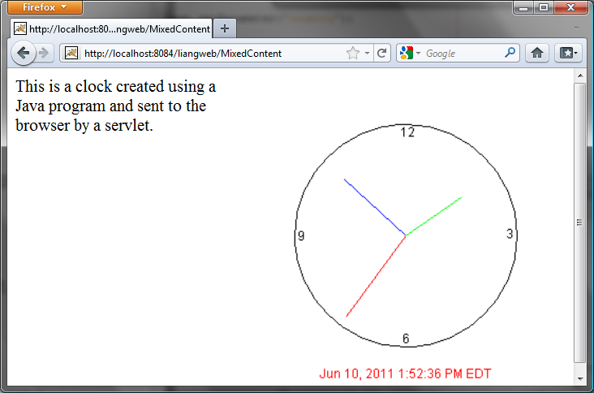
Figure 42.27
The servlet returns an image along with the text.

Listing 42.15 MixedContent.java
<Side Remark line 9: process GET>
<Side Remark line 11: content type>
<Side Remark line 14: get parameter>
<Side Remark line 16: image tag>
<Side Remark line 22: close stream>

package chapter42;

import javax.servlet.*;
import javax.servlet.http.*;
import java.io.*;

public class MixedContent extends HttpServlet {
/** Process the HTTP Get request */
public void doGet(HttpServletRequest request, HttpServletResponse
response) throws ServletException, IOException {
response.setContentType("text/html");
PrintWriter out = response.getWriter();

String country = request.getParameter("country");

out.println("<img src = \"" +
"ImageContentWithDrawing\" align=right>");

out.println("This is a clock created using a Java program " +
"and sent to the browser by a servlet.");

out.close();
}
}
The servlet generates an HTML file with the image tag

<img src = "ImageContentWithDrawing" align = "right">

The HTML file is rendered by the browser. When the browser sees the image tag, it sends the request to the server. ImageContentWithDrawing, created in Listing 42.14, is invoked to send the image to the browser.

Key Terms

- Common Gateway Interface
- CGI programs
- cookie
- GET and POST methods
- GlassFish
- HTML form
- URL query string
- servlet
- servlet container (servlet engine)
- servelt life-cycle methods
- Tomcat

Chapter Summary
- A servlet is a special kind of program that runs from a Web server. Tomcat and GlassFish are Web servers that can run servlets.
- A servlet URL is specified by the host name, port, and request string (e.g., Hhttp://localhost:8084/liangweb/ServletClassH). There are several ways to invoke a servlet: (1) by typing a servlet URL from a Web browser, (2) by placing a hyper link in an HTML page, and (3) by embedding a servlet URL in an HTML form. All the requests trigger the GET method, except that in the HTML form you can explicitly specify the POST method.
- You develop a servlet by defining a class that extends the HttpServlet class, implements the doGet(HttpServletRequest, HttpServletResponse) method to respond to the GET method, and implements the doPost(HttpServletRequest, HttpServletResponse) method to respond to the POST method.
- The request information passed from a client to the servlet is contained in an object of HttpServletRequest. You can use the methods getParameter, getParameterValues, getRemoteAddr, getRemoteHost, getHeader, getQueryString, getCookies, and getSession to obtain the information from the request.
- The content sent back to the client is contained in an object of HttpServletResponse. To send content to the client, first set the type of the content (e.g., html/plain) using the setContentType(contentType) method, then output the content through an I/O stream on the HttpServletResponse object. You can obtain a character PrintWriter stream using the getWriter() method and obtain a binary OutputStream using the getOutputStream() method.
- A servlet may be shared by many clients. When the servlet is first created, its init method is called. It is not called again as long as the servlet is not destroyed. The service method is invoked each time the server receives a request for the servlet. The server spawns a new thread and invokes service. The destroy method is invoked after a timeout period has passed or the Web server is stopped.
- There are three ways to track a session. You can track a session by passing data from the servlet to the client as a hidden value in a dynamically generated HTML form by including a field such as <input type=”hidden” name=”lastName” value=”Smith”>. The next request will submit the data back to the servlet. The servlet retrieves this hidden value just like any other parameter value using the getParameter method.
- You can track sessions using cookies. A cookie is created using the constructor new Cookie(String name, String value). Cookies are sent from the server through the object of HttpServletResponse using the addCookie(aCookie) method to tell the browser to add a cookie with a given name and its associated value. If the browser already has a cookie with the key name, the value will be updated. The browser will then send the cookie with any request submitted to the same server. Cookies can have expiration dates set, after which they will not be sent to the server.
- Java servlet API provides a session-tracking tool that enables tracking of a large set of data. A session can be obtained using the getSession() method through an HttpServletRequest object. The data can be stored as objects and are secure because they are kept on the server side using the setAttribute(String name, Object value) method.
- Java servlets are not limited to sending text to a browser. They can return images in GIF, JPEG, or PNG format.

Test Questions
Do the test questions for this chapter online at www.cs.armstrong.edu/liang/intro9e/test.html.

Review Questions
Sections 42.1-42.2
42.1 What is the common gateway interface?
42.2 What are the differences between the GET and POST methods in an HTML form?
42.3 Can you submit a GET request directly from a URL? Can you submit a POST request directly from a URL?
42.4 What is wrong in the following URL for submitting a GET request to the servlet FindScore on host liang at port 8084 with parameter name?
http://liang:8084/findScore?name=”P Yates”

42.5 What are the differences between CGI and servlets?
Section 42.3
42.6 Can you display an HTML file (e.g. c:\test.html) by typing the complete file name in the Address field of Internet Explorer? Can you run a servlet by simply typing the servlet class file name?
42.7 How do you create a Web project in NetBeans?
42.8 How do you create a servlet in NetBeans?
42.9 How do you run a servlet in NetBeans?
42.10 When you run a servlet from NetBeans, what is the port number by default? What happens if the port number is already in use?
42.11 What is the .war file? How do you obtain a .war file for a Web project in NetBeans?
Section 42.4
42.12 Describe the life cycle of a servlet.
42.13 Suppose that you started the Web server, ran the following servlet twice by issuing an appropriate URL from the Web browser, and finally stopped Tomcat. What was displayed on the console when the servlet was first invoked? What was displayed on the console when the servlet was invoked for the second time? What was displayed on the console when Tomcat was shut down?
import javax.servlet.*;
import javax.servlet.http.*;
import java.io.*;

public class Test extends HttpServlet {
public Test() {
System.out.println("Constructor called");
}

/** Initialize variables */
public void init() throws ServletException {
System.out.println("init called");
}

/** Process the HTTP Get request */
public void doGet(HttpServletRequest request,
HttpServletResponse response)
throws ServletException, IOException {
System.out.println("doGet called");
}

/** Clean up resources */
public void destroy() {
System.out.println("destroy called");
}
}

Sections 42.5-42.7
42.14 What would be displayed if you changed the content type to “html/plain” in Listing 42.2, CurrentTime.java?
42.15 The statement out.close() is used to close the output stream to response. Why isn’t this statement enclosed in a try-catch block?
42.16 What happens when you invoke request.getParameter(paramName) if paramName does not exist?
42.17 How do you write a text field, combo box, check box, and text area in an HTML form?
42.18 How do you retrieve the parameter value for a text field, combo box, list, check box, radio button, and text area from an HTML form?
42.19 If the servlet uses a database driver other than the JDBC-ODBC driver, where should the driver be placed in NetBeans?
Section 42.8
42.20 What is session tracking? What are three techniques for session tracking?
42.21 How do you create a cookie, send a cookie to a browser, get cookies from a browser, get the name of a cookie, set a new value in the cookie, and set cookie expiration time?
42.22 Do you have to create five Cookie objects in the servlet in order to send five cookies to the browser?
42.23 How do you get a session, set object value for the session, and get object value from the session?
42.24 Suppose you inserted the following code in line 53 in Listing 42.11.
httpSession.setMaxInactiveInterval(1);

What would happen after the user clicked the Confirm button from the browser? Test your answer by running the program.
42.25 Suppose you inserted the following code in line 53 in Listing 42.11.
httpSession.setMaxInactiveInterval(-1);

What would happen after the user clicked the Confirm button from the browser?
Section 42.9

42.26 What output stream should you use to send images to the browser? What content type do you have to set for the response?
42.27 How do you deal with dynamic contents with images and text?

Programming Exercises
NOTE: Solutions to even-numbered exercises in this chapter are in exercise\servletexercise from evennumberedexercise.zip, which can be downloaded from the Companion Website.

Section 42.5
42.1*
(Factorial table) Write a servlet to display a table that contains factorials for the numbers from 0 to 10, as shown in Figure 42.28a.
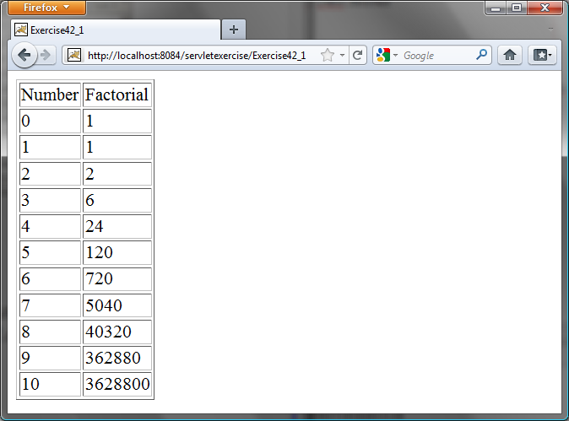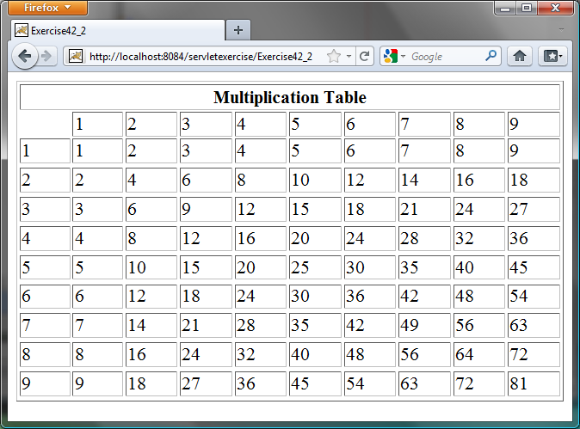

(a) (b)

Figure 42.28
(a) The servlet displays factorials for the numbers from 0 to 10 in a table. (b) The servlet displays the multiplication table.
42.2*
(Multiplication table) Write a servlet to display a multiplication table, as shown in Figure 42.28(b).
42.3*
(Visit count) Develop a servlet that displays the number of visits on the servlet. Also display the client’s host name and IP address, as shown in Figure 42.29.

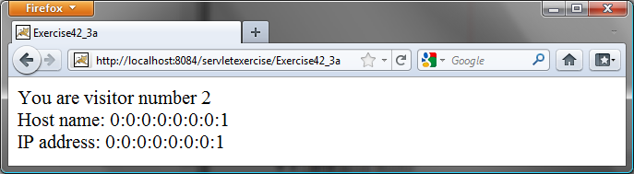

Figure 42.29
The servlet displays the number of visits and the client’s host name, IP address, and request URL.
Implement this program in three different ways:
  - Use an instance variable to store count. When the servlet is created for the first time, count is 0. count is incremented every time the servlet’s doGet method is invoked. When the Web server stops, count is lost.
  - Store the count in a file named Exercise39_3.dat, and use RandomAccessFile to read the count in the servlet’s init method. The count is incremented every time the servlet’s doGet method is invoked. When the Web server stops, store the count back to the file.
  - Instead of counting total visits from all clients, count the visits by each client identified by the client’s IP address. Use Map to store a pair of IP addresses and visit counts. For the first visit, an entry is created in the map. For subsequent visits, the visit count is updated.
Section 42.6
42.4*
(Calculate tax) Write an HTML form to prompt the user to enter taxable income and filing status, as shown in Figure 42.30a. Clicking the Compute Tax button invokes a servlet to compute and display the tax, as shown in Figure 42.30b. Use the computeTax method introduced in Listing 3.7, ComputingTax.java, to compute tax.

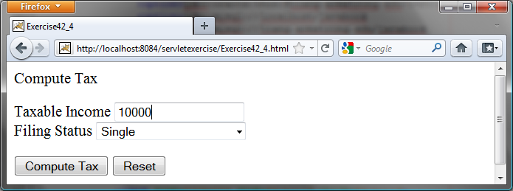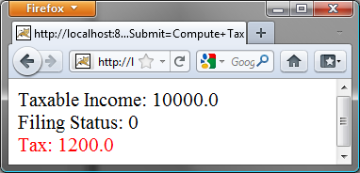

(a) (b)

Figure 42.30
The servlet computes the tax.
42.5*
(Calculate loan) Write an HTML form that prompts the user to enter loan amount, interest rate, and number of years, as shown in Figure 42.31a. Clicking the Compute Loan Payment button invokes a servlet to compute and display the monthly and total loan payments, as shown in Figure 42.31b. Use the Loan class given in Listing 10.2, Loan.java, to compute the monthly and total payments.

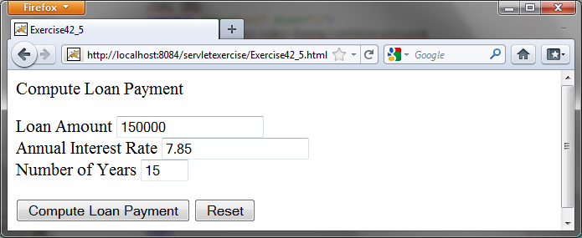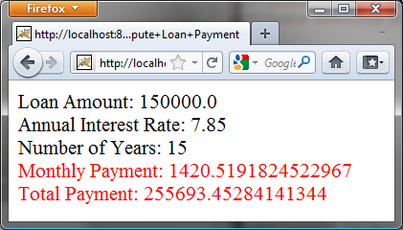

(a) (b)

Figure 42.31
The servlet computes the loan payment.
42.6**
(Find scores from text files) Write a servlet that displays the student name and the current score, given the SSN and class ID. For each class, a text file is used to store the student name, SSN, and current score. The file is named after the class ID with .txt extension. For instance, if the class ID were csci1301, the file name would be csci1301.txt. Suppose each line consists of student name, SSN, and score. These three items are separated by the # sign. Create an HTML form that enables the user to enter the SSN and class ID, as shown in Figure 42.32a. Upon clicking the Submit button, the result is displayed, as shown in Figure 42.32b. If the SSN or the class ID does not match, report an error. Assume three courses are available: CSCI1301, CSCI1302, and CSCI3720.

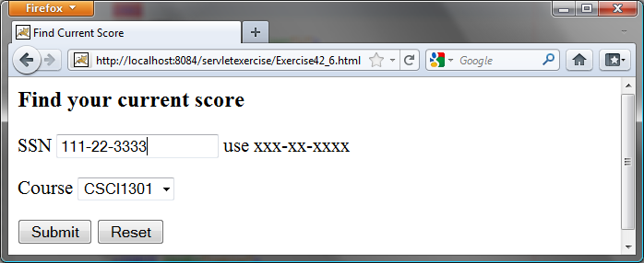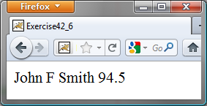

(a) (b)

Figure 42.32
The HTML form accepts the SSN and class ID from the user and sends them to the servlet to obtain the score.
Section 42.7
42.7**
(Find scores from database tables) Rewrite the preceding servlet. Assume that for each class, a table is used to store the student name, ssn, and score. The table name is the same as the class ID. For instance, if the class ID were csci1301, the table name would be csci1301.
42.8*
(Change the password) Write a servlet that enables the user to change the password from an HTML form, as shown in Figure 42.33a. Suppose that the user information is stored in a database table named Account with three columns: username, password, and name, where name is the real name of the user. The servlet performs the following tasks:
- Verify that the username and old password are in the table. If not, report the error and redisplay the HTML form.
- Verify that the new password and the confirmed password are the same. If not, report this error and redisplay the HTML form.
- If the user information is entered correctly, update the password and report the status of the update to the user, as shown in Figure 42.33b.

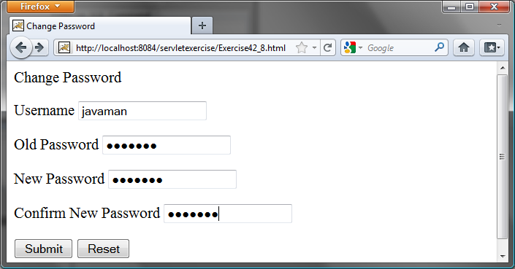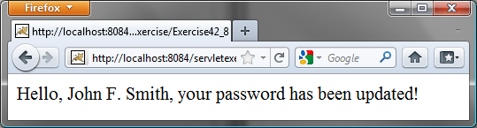

(a) (b)

Figure 42.33
The user enters the username and the old password and sets a new password. The servlet reports the status of the update to the user.
42.9**
(Display database tables) Write an HTML form that prompts the user to enter or select a JDBC driver, database URL, username, password, and table name, as shown in Figure 42.34a. Clicking the Submit button displays the table content, as shown in Figure 42.34b.

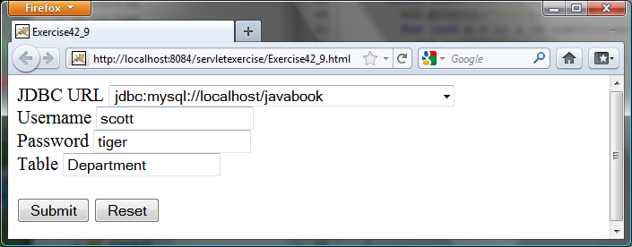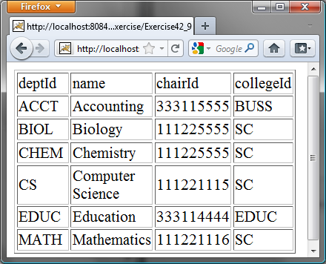

(a) (b)

Figure 42.34
The user enters database information and specifies a table to display its content.
Section 42.8

42.10*
(Store cookies) Write a servlet that stores the following cookies in a browser, and set their max age for two days.
Cookie 1: name is “color” and value is red.
Cookie 2: name is “radius” and value is 5.5.
Cookie 3: name is “count” and value is 2.
42.11*
(Retrieve cookies) Write a servlet that displays all the cookies on the client. The client types the URL of the servlet from the browser to display all the cookies stored on the browser. See Figure 42.35.

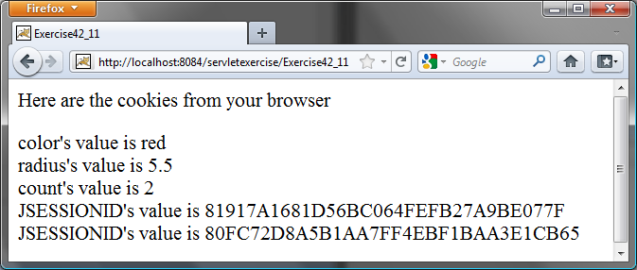

Figure 42.35
All the cookies on the client are displayed in the browser.
Comprehensive
42.12***
(Syntax highlighting) Create an HTML form that prompts the user to enter a Java program in a text area, as shown in Figure 42.36a. The form invokes a servlet that displays the Java source code in a syntax-highlighted HTML format, as shown in Figure 42.36b. The keywords, comments, and literals are displayed in bold navy, green, and blue, respectively.

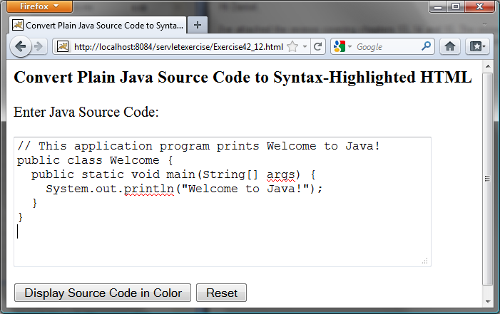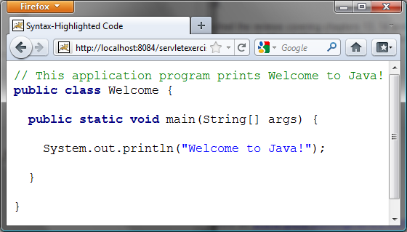

(a) (b)

Figure 42.36
The Java code in plain text in (a) is displayed in HTML with syntax highlighted in (b).
42.13**
(Access and update a Staff table) Write a Java servlet for Exercise 33.1, as shown in Figure 42.37.

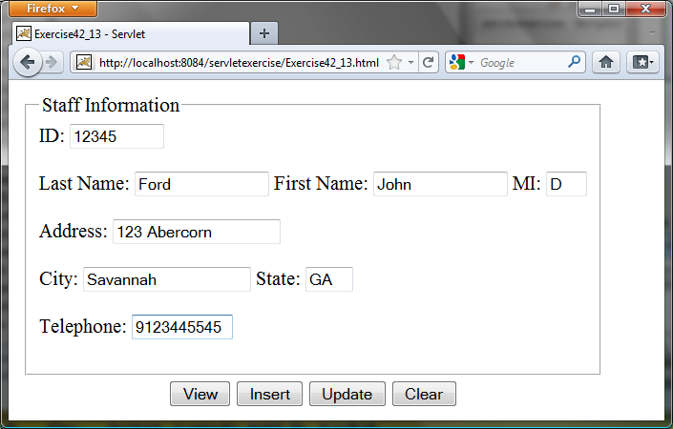

Figure 42.37
The web page lets you view, insert, and update staff information.
42.14***
(Opinion poll) Create an HTML form that prompts the user to answer a question such as “Are you a CS major?”, as shown in Figure 42.38a. When the Submit button is clicked, the servlet increases the Yes or No count in a database and displays the current Yes and No counts, as shown in Figure 42.38b.
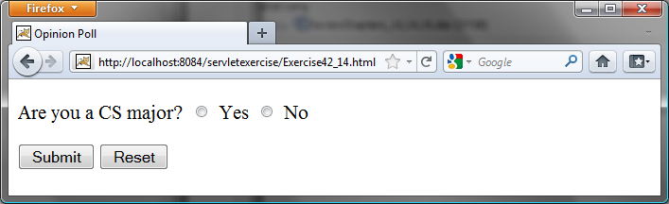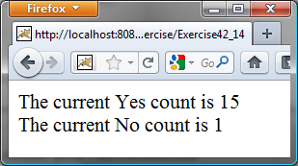

(a) (b)

Figure 42.38
The HTML form prompts the user to enter Yes or No for a question in (a), and the servlet updates the Yes or No counts (b).
Create a table named Poll, as follows:
create table Poll (
question varchar(40) primary key,
yesCount int,
noCount int);

Insert one row into the table, as follows:

insert into Poll values ('Are you a CS major? ', 0, 0);

